DWELLING PRACTICES AND THE REPRODUCTION OF MARGINALITY AMONG THE MBANDERU OF NGAMILAND, BOTSWANA

CHRISTOPHER MORTON

The Mbanderu of Botswana are a people closely related to the Herero, both communities having been displaced by German colonial aggression in Namibia in 1896/7 and 1904/5. However, little ethnographic attention has been paid thus far to this marginalised pastoralist community in Botswana. The paper outlines Mbanderu dwelling practices around Lake Ngami, examining concepts such as cooperation within their established grazing lands (ekondua rimue), the relation between dry and wet season dwelling sites, and their associated material practices, as well as the way in which burial, homestead abandonment and rebuilding are intimately connected in the landscape. Finally, the situation of Ovambanderu living in the town of Maun is considered, and the argument made that perceptions of socio-political marginalisation within Botswana, and suspicion of state attitudes towards them, on the part of Mbanderu are reproduced through the material practices of dwelling in the town, where a state of ‘permanent temporariness’ is recreated over time through dwelling activities.

Keywords: Botswana, Mbanderu, pastoralism, building practices, settlement, burial

Introduction

This article considers settlement and building practices of the pastoral Mbanderu people of Lake Ngami region in northern Botswana. The Mbanderu are a people closely related to the Herero, with whom they share considerable social and cultural similarities, as well as a history of migration into Botswana around the turn of the twentieth century, fleeing warfare and persecution in Namibia (Pennington and Harpending 1991). Both groups speak dialects of the same language, and both maintain a similar double descent pattern of social organisation, based upon the omaanda (sn. eanda), sometimes termed matriclans or mother groups, as well as the otuzo (sn. oruzo), again sometimes termed patriclans or father groups. However, both the Mbanderu and Herero of Botswana consider themselves as distinct peoples. This article constitutes the first detailed ethnographic account of the Mbanderu in Botswana. Of the existing literature on the Herero and Mbanderu in Botswana, Vivelo (1977) deals with some aspects of Herero culture, including homestead design, and Algamor (1980) deals with external perceptions of them as not integrating into Tswana society, arguing that their strong assertion of Namibian identity finds most expression in their maintenance of a pastoral identity in Ngamiland. The continuing social experience of uncertainty among the Mbanderu community with regards to their homeland, even more than a century after forced migration, is characterized by a permanent temporariness, affecting a wide range of social and economic activities. This finding corresponds with that of Parkin (1999) concerning the prolonged contexts of displacement found among refugees even many years after resettlement, in which uncertainty about relationships between persons, places, possessions and identities can be socially reproduced over time.
This experience was widespread for instance in the area settled by Mbanderu in Maun, the largest town in Ngamiland, called Mabudutsane, where, as I discuss below, most inhabitants firmly believed that the Botswana government intended to forcibly evict them and use the land for commercial development. This perception of marginality and disenfranchisement partly explained the low registration by Mbanderu of plots with the Land Board and thereby the lack of plot fencing in Mabudutsane ward. Whereas in the pre-Independence period land was understood as belonging to the Chief who had arbitrary control over people’s residential land, after Independence this sense of authority and possession was passed to the government. There is a strong continuity in perceptions about socio-juridical relations to land as an element of people’s perceptions about the nature of power and authority in Botswana that has important material implications in the relation between dwelling and building. I am not here arguing that an absence of any practice of freehold tenure means a lack of any ‘permanence’ in social relations to land or place, far from it. What interests me here is how indigenous notions of authority, possession and land relate to social activities, especially building activities, and how we might characterise these shifting relations.
Uncertainty over social relations to place exists perhaps on different scales and in different social and material contexts – for instance on the scale of the nation or of the homestead. On a national scale, relations between household and Chief, or between household and state, are the relevant social relationships for negotiation over rights to living, farming or exploiting natural resources in an area, or even concerning forced removal. Transience of dwelling has been an important social experience for Mbanderu people since their migration into Botswana, produced and reproduced materially through building practices, and is especially relevant when one considers the historical reluctance of Mbanderu to invest socially and materially in Botswana. This experience of permanent displacement or permanent temporariness has been documented occasionally in other research in Africa. In Permanent Pilgrims (1995) C. Bawa Yamba describes how ‘most of the inhabitants of the pilgrim villages in Sudan are third-, fourth-, even fifth-generation immigrants who have lived all their lives in Sudan, yet still regard themselves as being in transit. And not only do they define themselves as being on their way; to the outside observer, they live and act as if they were on their way’ (1995: 1). Differing perceptions about social relations to place between different groups are an important dimension of how social activities and material relations are configured within the landscape.
The multi-locational aspect of this article reflects such diverse and fluid sets of experiences, characterised by frequent movement between locales and dwelling sites within the landscape. Such movement is an important and integral dynamic of social life for the Mbanderu. Whilst on one level such pathways are an integral part of a group’s material and dwelling strategies, there are important social dimensions to movement occasioned by visiting, gifting, sharing in tasks etc. – paths allow and create the potential for arrivals and departures, the path of life and finally of death. Mbanderu people talked often of the paths (ditsela) that unite homesteads in the landscape, not just a metaphor for social ties but a description of how social relations are carried out in an everyday sense.
It is not my intention in this article to offer an exhaustive historical overview of Mbanderu settlement change, from pastoral dwelling to multi-locational and semi-sedentary living, but rather to examine how shifting contexts within the landscape have affected dwelling experience and practices. I have examined such contextual change for the most part as an integral aspect of the inherent temporality of the taskscape, put forward by Ingold as ‘the entire ensemble of tasks, in their mutual interlocking’ (1993: 158). The concept of taskscape can be seen as an attempt to develop a dwelling perspective within the context of actual historical change within the landscape, and to explore the interconnectedness of social and material practices in the shaping of landscape and settlement patterns. Toward this I have structured the analysis into two distinct parts: firstly, an examination of the pastoral Mbanderu taskscape and the morphology of the cattle homestead, and secondly an examination of Mbanderu dwelling on the social and economic margins of the then rapidly urbanising regional centre of Maun.
Observations and comments on building activity in Africa can of course be found in a large number of monographs and anthropological studies, but relatively few have attempted to analyse building and use of space as a central concern (notable exceptions include Moore 1986; Blier 1987). Much of the neglect of buildings and building activity within anthropology can be seen as historically enmeshed in the particularities of the development of anthropology, especially in the UK, which saw material culture studies as increasingly peripheral to the analysis of social structure as developed by Durkeim, Radcliffe-Brown, Mauss and Lévi-Strauss. Houses themselves were of less interest to anthropologists than the notion of what the house constituted, that is, a ‘household’ or nuclear kin unit (see Carsten and Hugh-Jones (eds) 1995). The materiality of the house was subordinated to the way societies were seen to use houses to structure social relations, especially domestic arrangements for individuals during their life course. There is little understanding in such studies of how the house as material culture is an influential dimension of social relations. For some social anthropological studies, the house became invisible, a container for social relations rather than an active element. Carsten and Hugh-Jones (1995) indeed argue that the subordination of the materiality of the house in anthropology was partly connected with the nature of social anthropological fieldwork, whereby ‘houses get taken for granted... [i]n time, for both anthropologists and their hosts, much of what houses are and imply becomes something that goes without saying’ (1995: 4). The importance of a material approach to dwelling practices has been something that I have tried to address in earlier publications (Morton 2004, 2007) as well as in this article.

The Mbanderu

During 1896-7 and 1904-5 a series of migrations into Ngamiland took place. These were by Herero (pl. Ovaherero) and Mbanderu (pl. Ovambanderu) peoples fleeing (mostly without their cattle) from German colonial aggression in Namibia. Both Mbanderu and Herero are closely related pastoral groups whose fluidity of movement within the landscape is linked with movement of herds to new grazing. The Mbanderu had no centralised polity, but rather a double descent system of patri- and matriclan. The patriclan (otuzo) is essentially a kin-based religious system closely associated with ancestral spirits, with the matriclan (omaanda) associated with marriage and identity. According to Kandapaera (1992: 28) the Tawana allowed the Mbanderu to settle the Lake Ngami region (Sehitwa-Thololamoro area) subject to their acceptance of Tswana overlordship and colonial taxation policies (Hut Tax). Since they had no or few cattle following the ravages of both wars and rinderpest, they worked as servants (batlhanka) for Tawana in return for gradually building up their own herds through mafisa, a system of lending cows for another’s temporary use (such as milking, offspring etc). Poor relations with the Tawana in the early twentieth century however led to further Mbanderu migrations, especially to Chobe in 1918, and later to Rakops (Tsienyane) and Ghanzi districts further south.
The Lake Ngami region has nonetheless remained the main area for Mbanderu pastoral activity for over a century, with homestead locations entirely encircling the now mostly dry lakebed. When Livingstone visited the Lake in 1849 the lake was a vast stretch of fresh water, approximately 80 kilometres long by 40 kilometres wide. By the turn of the twentieth century, the lake had begun to dry considerably, and by the 1920s hardly any water remained. Geomorphologists increasingly believe that the gradual drying of the western tributaries of the Okavango delta has been the result of a gradual shift in flow eastwards, possibly caused by earthquakes and the shifting of numerous fault lines across the system that form part of the great East African rift system, as well as climate change. Whilst Lake Ngami is now largely a historical lake, it still occasionally receives enough rainwater during the wet season (Nov-March) to have shallow waters in some areas, and some Mbanderu families live in and around the village of Sehitwa (Figure 1), on what was once the northern shore of the lake, including the family of their acknowledged leader in Botswana.

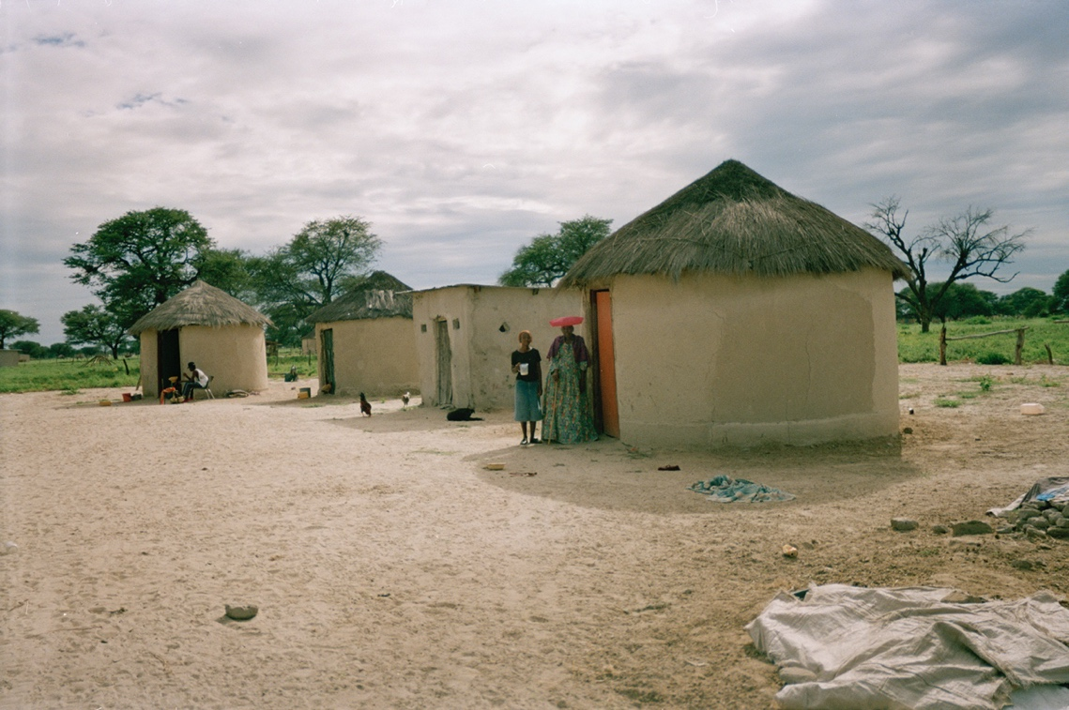
Figure 1 – Mbanderu homestead in Sehitwa, with doors facing west. Photo by the author, 2000. Courtesy Pitt Rivers Museum, University of Oxford [PRM2009.168.285].

The Mbanderu Social Landscape

The Mbanderu of the Lake Ngami area understand their region as a single unity, referred to as ekondua rimue – rimue being the term used to describe people affiliated to the same descent group. The ekondua rimue is considered an area of pastoral activity within which each Mbanderu has social rights of movement and dwelling with his cattle. This sense of fluidity was expressed in responses to the Tribal Grazing Land Programme of the government of Botswana, which they termed ondorota no ongaruhe, ‘fences there for ever’ (Algamor 1980), that is, fencing that would restrict the free movement of people and cattle within their region. The notion of ekondua rimue is an important context that frames the everyday pastoral taskscape. Many Mbanderu argue that fencing within the ekondua rimue should not be ‘there for ever’ in the manner of private ranches, demarcating private land. The ekondua rimue is understood as loosely arranged into differing named ‘locations’ where certain households consider their grazing areas to be. Such locations have ‘their own’ rainy season pasture into which they move with their cattle when the rains come, and whilst this does not mean that a household must graze the same specific pasture each rainy season, it usually moves to a pasture area that is known as the grazing ground of their locality. The pattern of moving to pasture zones associated with specific localities seems to be relatively fixed over time.
Although within each locality important socially co-operative practices exist, many people saw their closest social connections outside of their locality, since although close genealogical relations used to bind people to localities in the past, this no longer seemed to be the case. One of the effects of expansive settlement around the lake periphery seems to have been the breaking off of agnatic sub-units (e.g. sons with their families) into new localities, which effectively weakened some social links between sub-groups, yet reinforced social ties at the level of the sub-unit homestead. The expansion of sub-units into localities is facilitated by the fact that cattle are identified as belonging to individuals rather than being communally owned within a collective herd. Livestock units belonging to social sub-units cared for in the same cattle pen are seen as inherently separable, and this enables groups to come together co-operatively and yet move apart again.
The meaning of ‘locality’ for families is layered. On one level a man will describe a certain area, for example where his mother or father is buried, as a place where he has ‘rights’, as well as listing other localities with which he has an oruzo (patriclan), eanda (matriclan), or ovakue (affinal) connection. On another level, all localities within the ekondua rimue are felt to be interconnected due to the nature of such social bonds. Algamor has noted that ‘the issue of different locations might seem to be ecological, but it is, in effect, social’ (1980:53). I would rather see both ecological and social dimensions of location and place within the pastoral taskscape as essentially interconnected aspects of dwelling, and the Mbanderu ‘location’ as a process of dwelling involving interconnected social, material and ecological relations. The often-expressed notion (in Setswana) re masika rotlhe, ‘we are all kin’, was used to explain the notion and practice of free movement within the ekondua rimue, a connectivity to various aspects of the landscape that is created, maintained and expressed through reciprocal economic and social relations. For example, drought may badly affect grazing in some localities, and this may initiate a movement of people into other people’s areas that have been less badly affected, and this is seen as being possible since there will undoubtedly exist complex social ties to neighbouring groups established over time.
Mbanderu cattle dwelling sites take the form of onganda (pl. ozonganda) or main homestead, and ohambo (pl. ozohambo) or wet season grazing camp. According to Kandapaera (1992), ozonganda were frequently moved in the past, in search of better dry season grazing and water sources, and the ohambo moved in relation to the onganda within the locality. The notion of ekondua rimue is essentially a spatial one since it describes a certain network of established grazing locations but is also particularly social. As Casey (1996) argues, we should perhaps instead think about landscape in terms of its ‘placiality’ rather than spatiality and consider the Mbanderu ekondua rimue as a ‘socio-placial’ term. As such, it expresses an understanding of landscape in which places of pastoral activity and social interaction are interwoven in the production of meaning. As Harvey has noted, differing modes of production and social formations ‘embody a distinctive bundle of time and space practices and concepts’ (1992: 204). This said, both spatial and temporal aspects of ekondua rimue should also be grounded in material processes, since it is through these processes, which I now turn to, that social relations are expressed and communicated (Lemonnier 2012).

The nuclear homestead (onganda)

The Mbanderu homestead or onganda is the centre of pastoral, social, and even religious activity. Without any centralised social or political system, it is the onganda, and especially that of the head of a patriclan, that serves as a social and ritual focus. From an Mbanderu perspective, the central part of any onganda is the cattle pen (otjiunda), in relation to which the household head builds his house, and his family in relation to him. The cattle and the everyday tasks associated with them form the nexus of life within the homestead. One of the most consistent features of the internal organisation of the onganda is the positioning of the main house (ondjeuo onene yo okuruo) occupied by the head of the household and his wife, with respect to the cattle pen. Almost invariably this house is built with the door facing the main cattle pen in a westerly (kukuhitira ejuva) direction, and a visible path leads from this house to the entrance of the pen in which calves are kept apart from the milk cows. To the left of the main house as it faces the cattle pen, curving away in a semi-circle are the houses of the sons (omuatje uomuzandu), and to the right the daughters (omuatje uomukazona), with the first born (omuatje uomutenga) furthest away, and the last born (omuatje uomaanderu) closest to the main house. In polygamous households, the first wife (omusuverua uandje) occupies the main house (Figure 2), and other wives build beyond the eldest son to the left. Over time, these relative social positions are altered by additional marriages, as well as the building activities of maturing children of the homestead, all of which result in movement of house positions within the homestead.
The path between the main house and the cattle pen also serves to orient important religious practices within the homestead. Mbanderu religious practice is centred upon the spiritual intercession of ancestors between living family members and a supreme but remote deity. Within the homestead such religious practice is centred upon the ritual hearth (okuruo) that is situated just to the right of the path between the main house and the cattle pen. Next to the ritual hearth is an upturned thorn bush (etho), which is ritually linked to the okuruo (Figure 3). Not all homesteads are responsible for keeping okoruo and etho, since they are inheritable within a patriclan from father to son or between brothers. It is relatively common for sons to refuse to inherit the okuruo and etho if they are churchgoers, in which case they may pass the responsibility on to another male relation.

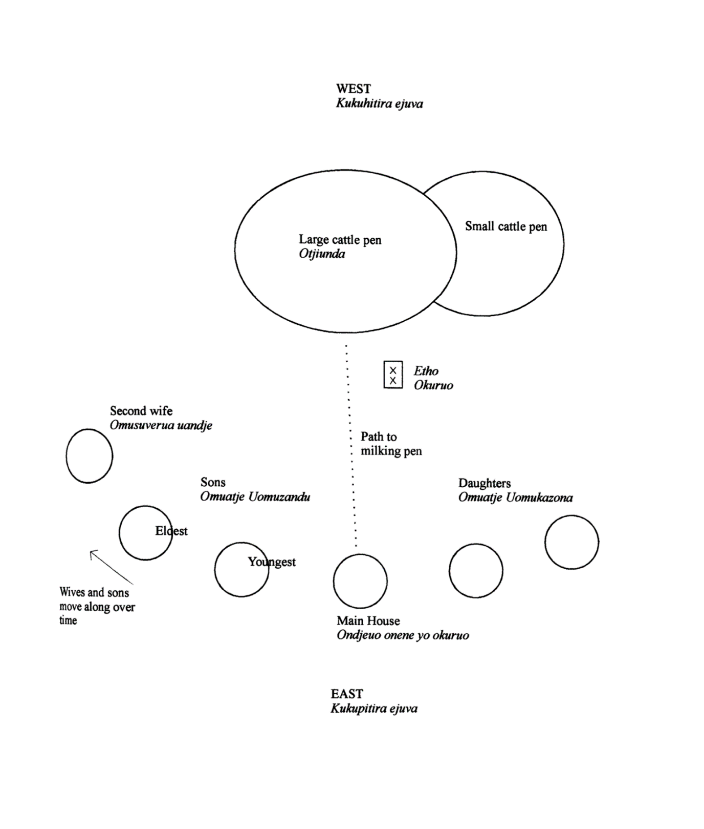
Figure 2 – Normative layout of house positions and dynamics in an Mbanderu onganda (homestead).

The etho consists of a small thorn bush (normally Blackthorn, Acacia detinens) which symbolises the revered omumborumbonga tree (Leadwood, Combretum imberbe), which is widely held by Mbanderu to be associated with ancestral spirits. The etho bush is collected by pulling up a bush (since its roots must be in place) and walking back to the onganda with it on the back. Both the okuruo and etho are used in the treatment of illnesses caused by ancestral displeasure, involving the ritual splashing (o kumba omeva) of the sick. Vivelo blames the loss of such ‘former descent-based activities such as reciprocal curing among patrisibs’ (1977: 76) for a breakdown of adherence to the ‘ideal’ homestead pattern. The Mbanderu headman in Sehitwa explained the okuruo to me as the ‘bringer of light and good luck’ (Setswana: mathogonolo) to both the immediate household as well as the extended patriclan. The association with light refers to the fact that the okuruo is lit each morning and evening by the main wife, or if she is away by another person, and that the well-being of the patriclan is connected to this ritual observance.
After visiting numerous onganda in western Ngamiland, it is clear that this arrangement of houses among the nuclear family, as well as the importance of orientation toward the west, is a consistent organisational principle that orders the onganda. When it comes to more complex family arrangements, over time different families approach building relations in a variety of ways. In the case of polygamous households many agree that a second wife should build to the left of the main house beyond the eldest son (of the first wife, if she has one), although some say she should build between this son and the main house. For a third wife, some say she should build between the second wife and the eldest son, and others that she should build to the right instead, with a fourth wife building to the left again. When questioned on cases of extended family households, responses regarding homestead organization are mostly based upon past experiences rather than any cultural norm.
Since the practices of previous generations are invariably seen as the source of Mbanderu social and cultural continuity, idealized notions of ‘Mbanderu culture’ expressed by informants are directly associated with memories of past ancestral practice rather than any abstract blueprint for dwelling. Vivelo’s search for such a blueprint of the Herero homestead, presumably following Bourdieu’s structuralist account of the Kabyle house (1970), shows just how misplaced the search for an ideal can be, for instance when he suggests that whilst ‘not one existing Herero homestead conforms to the ideal, it was confirmed as an ideal plan by all’ (1977: 34). In practice, he argues, most homesteads only roughly follow the ideal pattern and for the most part do not adhere to them at all. The major flaw with this sort of approach to the onganda is its lack of recognition that there is always a tension between past and current cultural practice which is generative of certain discourses concerning moral or social degeneration, cultural identity, ancestral displeasure, and so forth. This means that the search for idealized cultural patterns and their origins is dubious and, in any case, not historically useful in understanding the way in which material practices communicate social relations. Nonetheless, the diagrams presented in this paper were ones given to me directly by Mbanderu informants as structuring guides to their own family practice, and so worth presenting as such.

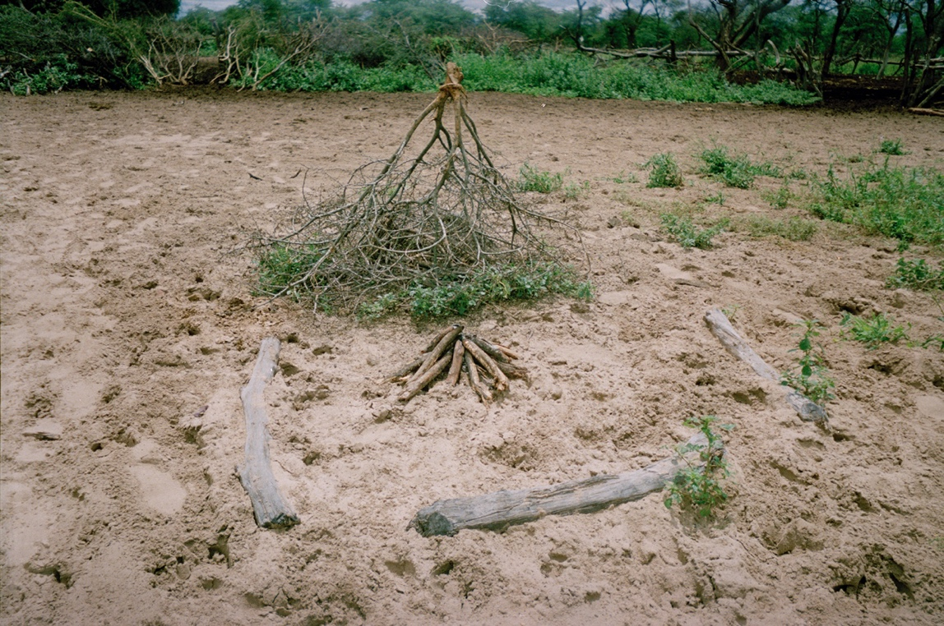
Figure 3 – The ritual hearth (okuruo) and thorn bush (etho) at an onganda in Ngamiland. Photo by the author, 2000. Courtesy Pitt Rivers Museum, University of Oxford [PRM2009.168.266].

The cattle camp (ohambo)

During the wet season (November-March) when surface water ponds are available, cattle may graze for some time away from grazing areas close to the onganda and its water source, usually a hand-dug well. Such suitable pastures are widely known and seem to be repeatedly visited by those grazing within certain locations. These remote cattle camps or ozohambo are often-revisited sites where houses and cattle pens are renewed with materials gathered in the bush close by. Thatching grasses are collected that will last the rainy season, and new poles may be cut from Terminalia trees, with walls in-filled with soil and cow dung mixture between horizontal supports. Visiting between the two locations (which may be a day or more away by foot) begins immediately, with milk, sourmilk and meat being brought back to the onganda, and other goods being taken to those staying at the ohambo. Those staying away with the cattle are likely to be young herders, but it is not uncommon for women to be there also, milking and making sourmilk. The ohambo is built in a similar manner to the onganda, but is likely to have fewer buildings since most of the family will only visit for relatively short periods. The important ancestral fire and thorns do not move to the ohambo during the wet season, and elderly and young children may also remain behind. It would be wrong to consider the ohambo as an inherently temporary wet season dwelling site in relation to the relatively permanent onganda. The social landscape of Lake Ngami is perceived as divisible into locations, each containing interdependent dry and wet season grazing areas. Wet season grazing areas are relatively consistent within the landscape over time, and are perceived as being just as ‘permanent’ as village sites. Also, although building practices and other material investments at the ohambo involve less labour when compared to the onganda, the ohambo is not inherently perceived as ‘temporary’ in a social sense. The period of time at the ohambo is remarked on by people as a time of intensified social activities, such as singing and dancing, which heighten its social and ritual importance to the group. This observation accords with other ethnographies of pastoral peoples, especially Evans-Pritchard’s classic discussion of the relationship between Nuer camps and villages, where the movement between sites during the year can make camps feel like villages, and villages like camps (Evans-Pritchard 1940: 63).
The pattern of moving between wet and dry season grazing sites has been affected over time by a combination of influences which has led to increasing semi-sedentary practices, such as village homesteads without any cattle and even agriculture. For most Mbanderu people living in villages such as Sehitwa, the onganda is a cattleless village or town homestead, and ohambo the remote cattle homestead, thus becoming roughly equivalent to the Tswana division between village home (motse) and cattle post (moraka). The fact that the term ohambo increasingly denotes a cattle post rather than a wet season grazing camp is significant in that it suggests the extent to which the Tswana model of village, cattle post and fields (motse, moraka le masimo) has been translated within an Mbanderu context.

From homestead to burial site

A deceased person is often buried within the homestead in a position dictated by their social relation to the household head (omuini). The cemetery at Sehitwa (the main Mbanderu village location) was being used as an alternative, especially for churchgoers. If an omuini dies and is buried in the homestead then an Mbanderu family will move away, although often only up to a kilometre, and the old home abandoned. Other members of the family may be buried in the homestead without precipitating a move. Whilst for groups such as the Yeyi burial in the homestead is not incompatible with continued residence, and in fact produces closer social relations to place, for the Mbanderu the burial of the household head in the homestead leads to a shifting migration (o kutjinda), a movement that transforms the onganda into a burial site or etundu. The term etundu can indicate either a former dwelling place or burial site. Whilst all such burial sites are former dwelling places, not all former dwelling places are necessarily burial sites. One Mbanderu woman told me that moving after burial was a response to ‘not wanting to live among graves’, something echoed in Cyprian Ekwensi’s story of the pastoral Fulani of Northern Nigeria, Burning Grass: ‘Sunsaye was indeed well beloved and they buried him in great pomp on the spot where his first camp had been. Then they cleared away in great haste. For legend holds that the place where a man died is bad luck.’ (Ekwensi 1962: 118)
Another important facet of the etundu is the way that it becomes used as a burial ground for future generations. Indeed, unless a household have moved to a completely new location, family members are more likely to be buried at such an ancestral burial place close by than in their own homestead. If the omuini is not buried in the homestead, but in the etundu of his parents or grandparents or in a cemetery, many Mbanderu say that they need not migrate, although some argue that the homestead is associated with the deceased leader and the new omuini should establish his own onganda. If the family do not migrate, the new omuini will be expected to occupy the main house, although I have seen examples where he will not do so until the deceased leader’s main wife either leaves the house or dies. One informant, Tududa, told how his great-grandparents were buried in Namibia, but that his grandparents had been buried in their old onganda, which has become the family burial site (etundu) since his father and mother are also buried there. Another woman, Kautaponde, described how her husband had been buried in their homestead, after which they stayed there for about a year, during which time she was not supposed to milk the cows or even look toward the cattle pen (otjiunda) for fear of bad luck. Her eldest son then established a new homestead some distance away. However, another man, Johannes, argued that a migration should take place at most one to two months after a burial.
Whilst the burial of a former omuini precipitates a reorganisation within the household, it is the movement of the cattle pens to another site linked to a new household head that is perceived as the central dimension of migration. Inheritance and ownership of cattle socially defines the new omuini as a social nexus for the dwelling relations of other relations. This important dwelling relationship between cattle activities and sociality is also inherently a material process – the reconfiguration of social relations over time is spatially engaged with through the group’s material practices at the dwelling site, building and rebuilding the cattle pens, houses, and hearths as part of collective activity. Once new cattle pens have been made from cut thorn bushes, spatial (that is, building) relationships based upon each person’s relation to the new omuini of the main house (ondjeuo onene), are renegotiated. Within the homestead both building relationships and social relations are interwoven dimensions of dwelling experience. Whilst homestead movement precipitates a sudden reorganisation of these spatial relations within a homestead, when no migration takes place socio-spatial changes through building may be more gradual. Building, moving, and rebuilding are common experiences as socio-spatial relationships change over time. One informant, Uatira, described how his father’s second wife had had to rebuild three times, and himself twice, in order to accommodate the houses of younger brothers and their wives. The second wife then decided to move to the right side in order to avoid another move, even though she felt ‘wrong’ there on the side where normatively daughters build.
Another woman, Konee (Figure 4), pointed out that she is married to the eldest son in an onganda, and that they had had to move twice to make space for the second son after his marriage to two wives. Even though her husband was the omuini, his mother was still alive and they would only move into the ondjeuo onene (main house) after she died. The mother had not left the main house after the death of her husband because he had been buried elsewhere and they didn’t have to move. Konee also described how she and her husband crushed the old houses and took the useful parts away, even though it was the responsibility of the younger son ‘forcing us to move’ to gather materials for them. She also related how the family had moved from a previous place due to poor shade, and that her husband’s father had insisted he be buried there and to make it the etundu, ‘since he did not wish to force us to move from this new place as we all liked it’. Another elder woman, Mata, told how her husband had been buried at his parents’ etundu, and that she would also be buried there. Her eldest son would then move to occupy the main house, having previously moved once before to make room for the second wife of his younger brother.
If the new omuini or household leader (usually a son or brother) is to inherit the okuruo and etho (ancestral fire and thorn bush) from the previous homestead then additional practices are involved. When the previous omuini is buried, the okuruo and etho are taken from their place to the right and moved to the left of the path. Some describe this as a form of ‘death’ to accompany that of their custodian. The inheritor is usually an eldest son, or if he is unwilling (perhaps due to Church sensibilities) another senior male relative such as a brother. Two informants, Wahuma and Washiwa, described how the migration of the okuruo and etho always takes precedence, so that it is one of the first things done. ‘If the main house is not yet built, the place where the house fire is to be will be made, and after lighting it will be taken to the okuruo, made ready near the cattle pen’. The importance of this continuity is such that a stick from the previous okuruo is used in its migration. One elder in Sehitwa, Pata, described how he had inherited the okuruo and etho, ‘cutting a piece of Mogkalo (Blackthorn) across the grain rather than splitting it (go kgaola) and putting it in the okuruo. Whilst it was still burning, I brought it here to make a new okuruo.’ Pata used his parents’ okuruo fire to light his new house fire, which was then used to light the new okuruo the next day. In this way, ancestral continuity was assured between both ritual and home fires. Whilst there is no domestic cooking done on the okuruo since it is considered a ritual hearth connected with ancestral spirits within the homestead and patriclan at large, it is lit each morning from the main house hearth, normally by the senior wife, which establishes an ongoing relationship between daily dwelling activities and religious practice.

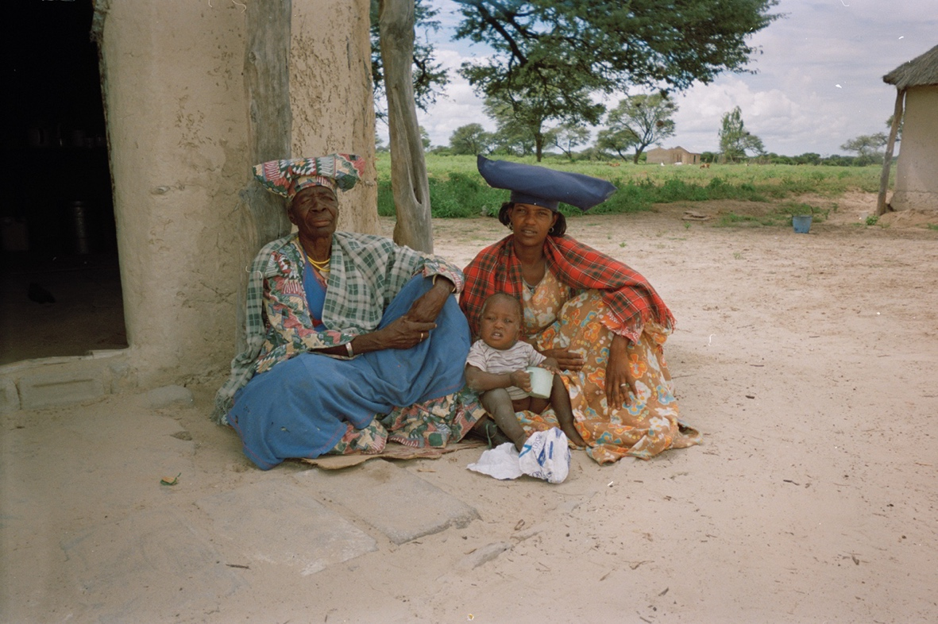
Figure 4 – Konee (right) with her child and mother-in-law, at their onganda near Sehitwa. Photo by the author, 2000. Courtesy Pitt Rivers Museum, University of Oxford [PRM2009.168.288].

Burial positions: Dwelling and transformation

In summary, burial is a practice carried out both within a homestead and at a former homestead or etundu. In general, the burial of family members other than the household head (omuini) may take place within the onganda (such as females within the cattle pen) without precipitating a migration. If the omuini is buried within the onganda then a new leader will normally re-establish a dwelling site a short distance away soon after. If the omuini is buried elsewhere (at an etundu or cemetery) then a migration may still occur, or the new leader may soon after inhabit the main house of the onganda. I now examine differences in the positioning of graves within the homestead and then after its transformation into an etundu. The transformation of a place from dwelling to burial site is an important one for the Mbanderu, which brings with it altered burial practices and social activities connected with the site.
In terms of burial practice within the homestead, discussion with at least a dozen households showed that certain consistent elements over time are evident. The most significant is the positioning of the grave (ombongo) of the omuini or male leader of the household, which is positioned outside of (and with head towards) the cattle pen (i.e. facing west), and to the right of the central path, close to the ancestral fire and thorn bush (okuruo and etho) (Figure 5). Wives of household members are usually buried within the smaller cattle pen, and the head of the woman should face toward the centre of the larger pen. Children should be buried beneath the thorn fence of the smaller pen, and the thorns replaced over it. One woman stated that ‘children are buried under the thorn fence so that their graves cannot be trampled by cattle…older people’s graves can support themselves but a child’s grave is too fragile to be stood on’. It was customary for generational lines of graves to move from right to left, so that some graves would be placed to the left of the path over time instead of to the right. It was considered that there should be a clear spatial division in the grave lines of males, women and children. However, all the graves should face west, said one man, ‘since everything has its own culture - even the birds build their nests in the trees facing west. I visit the etundu very often. If someone is sick I cut a twig from a thornless tree to show respect and place it on the graves as I call their names’.
Some Mbanderu reported that occasionally families departed from these norms, especially when building in the village setting of Sehitwa. For example, in the past, on the death of the household head, the door (omujeruo) of his house was said to have been removed and placed to one side. One informant, Johannes, related how formerly the door was made from the skin of a cow, and that this skin would be taken by the new omuini to found a new main house. However, it seems that although the door is still removed today to indicate respect for the deceased household leader, it is not necessarily inherited. In general, after migration none of the materials from the old main house are reused but left to decay. ‘We do not crush his house’, said another informant, ‘because we want the spirit of the man to remain in the onganda since he is buried there in the otjiunda’. ‘The first thing done at the new onganda is the construction of the otjiunda’ related one woman, ‘and whilst the new pen is being made the omuini will place a stick where the new main house will be, and it will be built there after’. Once this building is finished, the rest of the household would then build in spatial relation to it. Several other informants also said that they never took materials from an old homestead when establishing a new one, especially not the thorn fence. ‘Nothing is supposed to be taken’, one man insisted, ‘for instance for firewood, especially from the cattle pen for young cows since beneath these thorns a child may be buried. You see, the cattle pen is both the cradle and the grave of the onganda’.
The cattle pen, the otijiunda, is perceived as both the thorn fence boundary and the space created within, which together hold and gather the cattle of the homestead. The metaphor of the cradle is suggestive of the way this feature of the homestead is perceived as both protective and nurturing, not just of the cattle, but of the social existence of the household - its very identity and future well-being. In this sense the material boundary of the otijiunda gathers and nurtures the vulnerabilities of the symbiotic relation within the homestead between cattle and people, it is felt as demarcating a space connected with the ancestors.

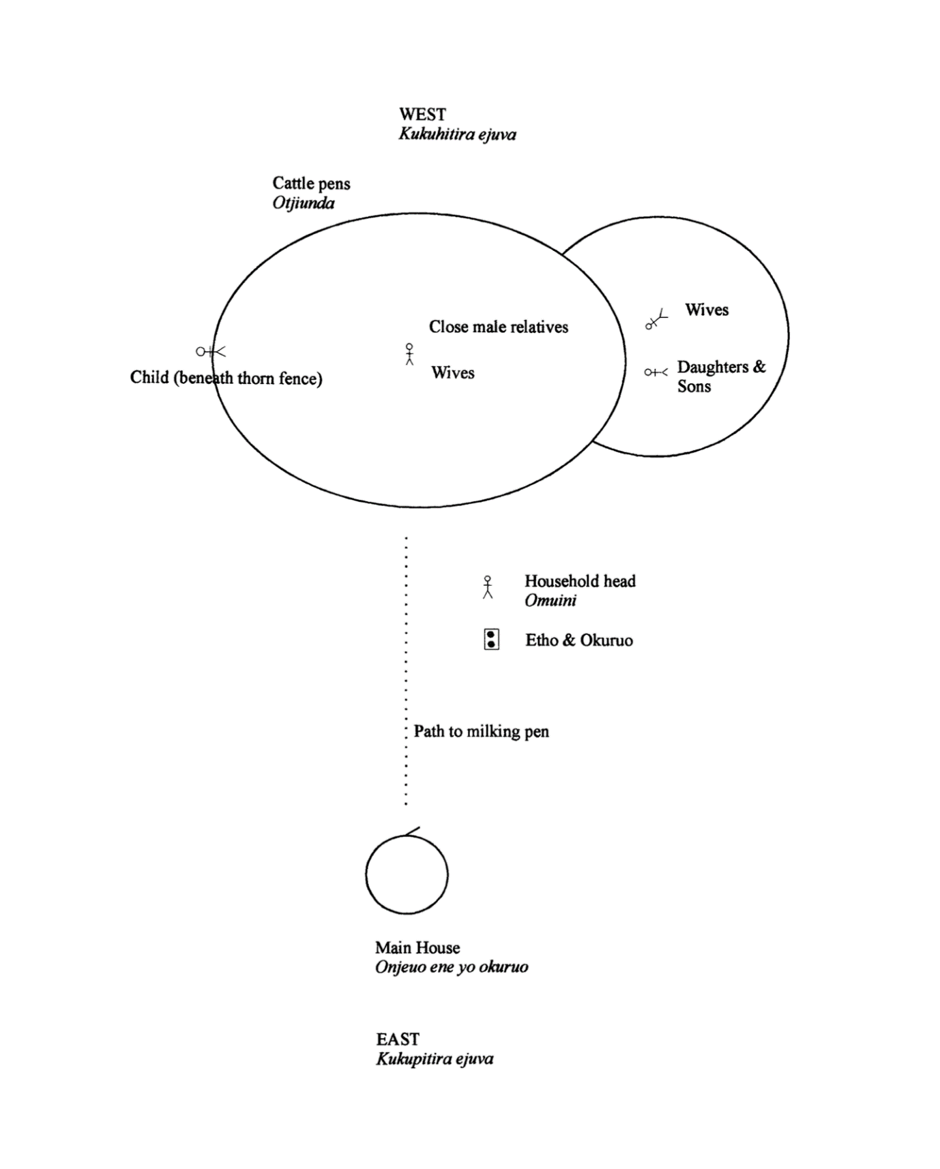
Figure 5 – Normative burial positions of family members in an Mbanderu onganda.

Most people see the otijiunda as situated outside of normal space and time relations within the onganda, and thereby in essence closely connected with religious practice. The ancestral and religious contexts in which the relations between cattle and people are bound make the otijiunda the material and spatial focus for ritual activity within the homestead.
The transformation of a homestead into a burial place is a process in which material and social forces are both at work. The importance of a temporal approach to the social landscape is evident here, since these places emerge as important to a process of dwelling, as events as much as sites. It is evident that the positioning of graves within the homestead is altered significantly when the homestead site becomes an etundu or burial place. Although there is a significant variation in burial practice, all Mbanderu distinguished between burial within a homestead (onganda) and a former homestead (etundu). To summarise this distinction, in the homestead people are buried in relation to the cattle pen as the social and ritual focus of dwelling, in a position dictated by their social identity within the homestead (i.e. wife, child etc.), whereas in the etundu, people are buried in relation to the graves of previous generations, and often in a line below them or to one side. In the example shown in Figure 6, the former cattle pens and houses have long since gone, the family having moved on the death of Tududa’s grandfather who was buried next to the milking pen. Tududa’s grandmother was also taken to be buried at this site some years later, as were his father and mother, in a line behind them. According to Tududa, future graves would not follow this line, but instead move to the other side of the former path, where graves will be placed according to their social relations to each other.
In another example (Figure 7) this mixture of generational and sex-based organisation at the etundu is shown. In this case however, clusters or areas of burial are used instead of lines, with the founding grave placed according to burial in the onganda (father of interviewee) and his mother to the left of the path. These two examples show how Mbanderu burial organisation at the etundu is considered mostly from the perspective of close kin ties, especially the relationship between the deceased and the ancestral founder of burial site.
This transformation of burial practice between the onganda and etundu within the same site is obviously closely connected with the temporality of dwelling, since it is the removal of the cattle from the former cattle pen to a new place that is fundamental to the process of social transformation. Within the etundu, the former cattle pen location is not regarded and is unimportant in the positioning of family graves. The importance, and meaning, of the cattle pen as a physical locus for burial within the homestead is interwoven with its role as a material container of the household cattle – it is its temporal dwelling context that is important in religious practice, rather than any abstract or symbolic meaning. Once the cattle have been removed, the otijiunda loses its meaning as a locus for ritual activity, especially burial.
One of the key elements arising from the examination of data on settlement discussed thus far is that of temporality, and how the consideration of movement through time is central to an understanding of socio-spatial change. In addition, it is the material practice of dwelling that grounds our concepts of spatiality and exerts an important influence on sociality in general. The way in which movements in the landscape are socially ordered is through an engagement with the various tasks of dwelling – the making of the cattle pen, the main house, the lighting and daily renewal of the fire – and the practice of such activities is involved in the creation and maintenance of social groupings.

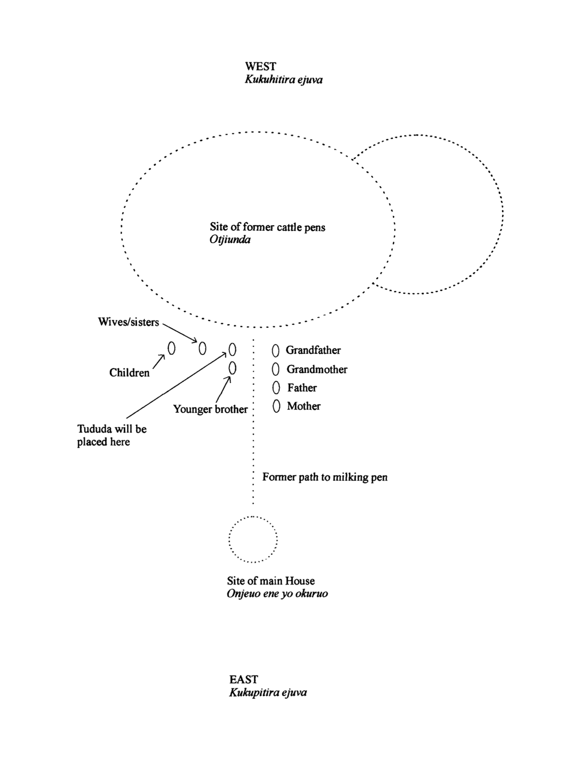
Figure 6 – Burial positions of Tutuda’s family at their etundu, the former homestead of his grandfather.

The way such social activities give rise to cultural forms such as the onganda or etundu is a shifting, temporal process, for instance in the way burial in the onganda is focused on the cattle pen (otjiunda) where everyday life is centred, whereas post-migration burials will normally focus spatially on relations to other graves. Moreover, the way in which the materiality of the onganda arises through dwelling activities, can be seen as exerting a mutual influence upon the social processes within the onganda over time, producing and reproducing an arena of socialisation. The temporal responsiveness of homestead forms to changes in this taskscape is such that socio-spatial relations within the onganda are frequently in a state of flux in response to the human lifecycle.

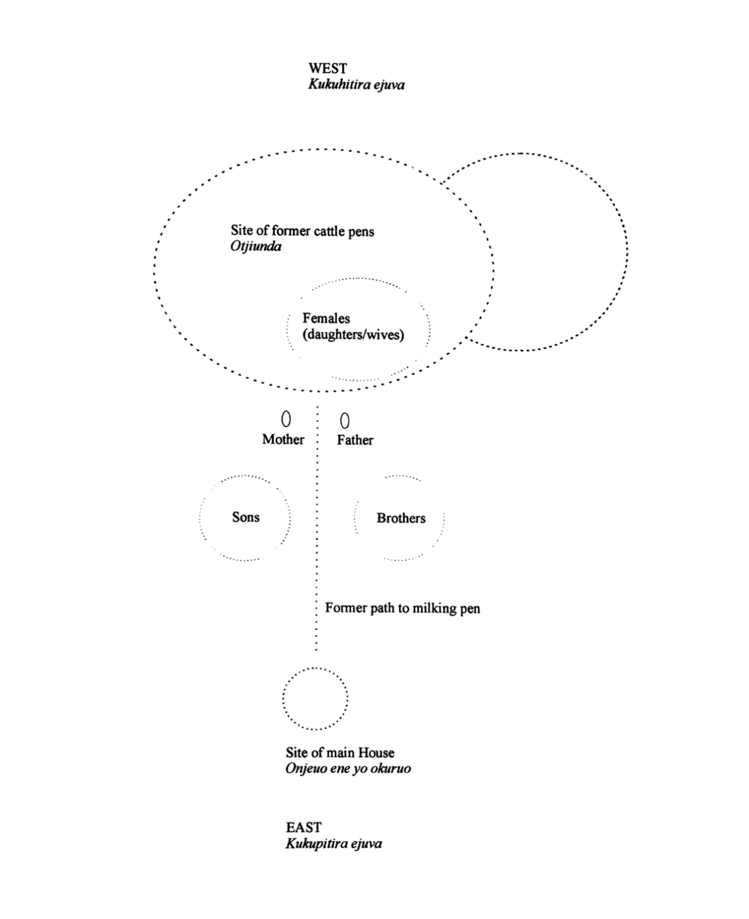
Figure 7 – Organisation of burials at an etundu (former homestead) in Ngamiland.

Reproducing displacement and marginality: Mabudutsane ward, Maun

I now turn to how the question of how these material practices of dwelling are transformed in the context of the Mbanderu ward of Mabadutsane (a sub-ward of the Tswana ward of Mabadutsa, sometimes colloquially known as ‘Herero village’) in the main regional town of Maun. It seems that there has been some Herero and Mbanderu presence in Maun since at least the 1930s, that is, shortly after the founding of the village. According to one woman, the first Herero inhabitants in Maun were two women, Enoke and Kangamero. Her own family have had a presence there since the early 1950s after the Tawana regent Elizabeth Pulane Moremi tried to influence the Herero headman Kaominga Kahaka to settle in Maun. Although some families were by 2000 cattle-less and permanently resident in Mabudutsane, the majority continued to consider Maun a place for schooling, visiting the hospital or relatives and purchasing goods, whilst most of their attention was directed toward cattle-based activities elsewhere. Frequent movement between remote ozohambo (cattle posts) and the ozonganda (homesteads) in Maun produced and reproduced networks of material and social exchange. As an arena of socialisation, Mabadutsane can be understood as having materially produced and reproduced social and temporal notions of displacement and marginality commonly expressed by its inhabitants. An examination of several case studies of family dwelling areas will help to ground this analysis.
Mabadutsane is on the western side of Maun, either side of the road in from Sehitwa. The Tswana headman of this ward, Rra Odirile, explained that since the Mbanderu have never been granted their own ward within Maun they lived there without any local political representation. Whilst the area is often known as ‘Herero village’, probably less than one third of its inhabitants identify themselves as Herero, with the majority claiming Mbanderu identity. I spent over six weeks in this roadside community, and conducted approximately thirty formal interviews with households, as well as numerous informal discussions and activities. I also produced a detailed plan of the portion of Mabudutsane on the south side of the Sehitwa road, between the road and the property of the U.C.C.S.A. (United Congregational Church of Southern Africa). Figure 8 shows the location of Mabadutsane as well as the area that I planned in detail, as well as recent satellite imagery that shows that the area remains largely unchanged in terms of Mbanderu occupation of the area, despite their fears of removal at the time.
Houses in Mabadutsane at this time were made from natural and salvaged materials rather than concrete blocks, as is more evident today. Corrugated iron shelters housed a number of drinking places where people grouped to purchase and drink sorghum beer. Most households comprised school children of varying ages, with female relatives taking care of them. Other noticeable groups were more transient and included people attending clinics or the village hospital, which was relatively close by, young males and females hoping for some cash work, people visiting and purchasing commodities, and women in informal employment.
A town planning report prepared on the area in 1991 concluded that: ‘the socio-cultural attributes of the predominantly Herero community in the area may have somehow also influenced the development of the unusual plot formations, which has unfortunately led to overcrowding. Young adults tend to erect their huts next to their parents on the same plot rather than move ... this suggests a desire to maintain strong family and community ties’ (Malila 1991:46).

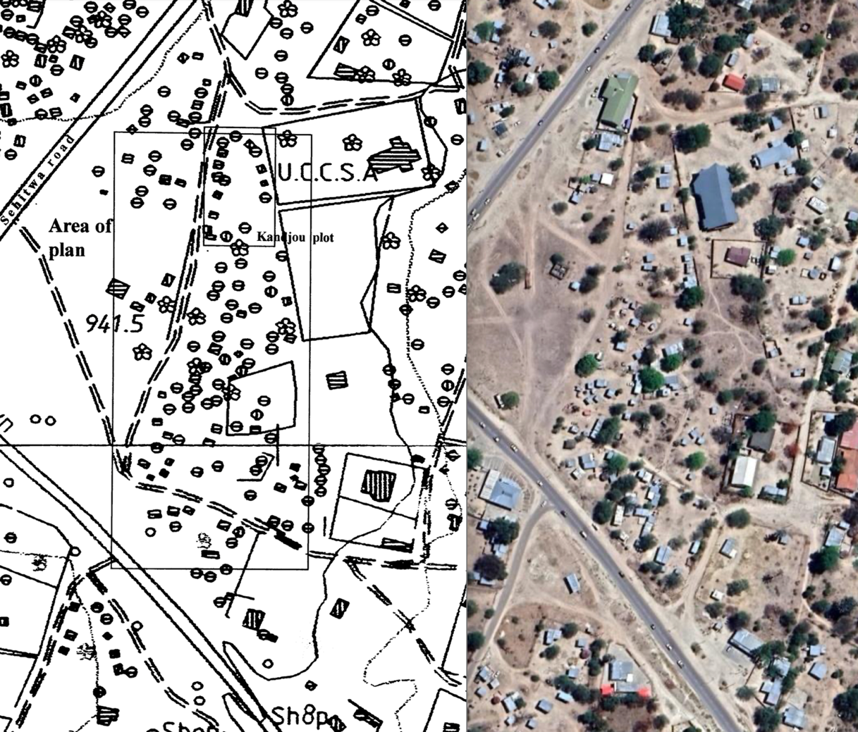
Figure 8 – (left) Location of Mabadutsane or ‘Herero village’ in Maun, showing area planned in detailed by author and location of one family grouping (Kandjou); (right) same area from Google satellite imagery in 2022.

Most of the homesteads in this area of Mabadutsane were unfenced, in contrast to most wards elsewhere in Maun, where plots were officially allocated and fenced, and more than one household usually built together as extended kin. In fact, this was partly intentional on the part of its inhabitants, who consider the area as a ‘base camp’ for Mbanderu and Herero people whilst in Maun, rather than a permanent home or ward of the town.
Over time, the number of houses had increased with extended family members joining each other, and since no formal plot boundaries existed, demarcation and formal Land Board-granted rights to living spaces were rare. On drawing a detailed plan, people were however able to identify their agreed dwelling areas. These areas were not simply where they carried out domestic activities such as cooking, but in fact were zones around houses belonging to specific relatives who had built with them. People often built houses in specific spots to incorporate the resulting space between buildings within ‘their’ area. This process, in which the practice of building creates and maintains social space, explains much about the socially recognised plot boundaries shown to me in Mabudutsane. ‘We never thought of fencing our areas’, said one woman, ‘since we are all related people staying in one place.’ ‘We don’t know how to organise ourselves in a village’, said another woman, ‘since there is no otjiunda or main house to build with’. ‘We do not need to separate ourselves with fences like the others in Maun,’ related another, ‘since we are all related people staying together, sharing our everyday things … you cannot live together with such boundaries’. ‘At the ohambo no-one is allowed to build behind another person, but you will find that here’ stated another woman, ‘my parents built in a line and this is better since we can see each other and communicate well’. It was noticeable when planning Mabadutsane how the building norms outlined in the first part of this paper did not feature here. Instead, most houses were influenced in their orientation by the hard boundaries of the main road and the wall and fence of the U.C.C.S.A. land to the south (Figure 8). Houses clustered and jostled for space, with doors facing all directions, rather than west.
Mabudutsane was therefore an inherently negotiable and fluid social area, made and remade through the material practices of building. It was characterised by a sense of long-standing temporariness or marginality, enhanced by its peripheral location squeezed between a main road and a church property, and without any formal recognition or land allocation by the local government authorities. What quickly became apparent was that this settlement was a product of the range of Mbanderu social and economic activities in Maun, activities that contrasted markedly with other resident groups. For the most part, most Mbanderu did not regard Mabadutsane as a secure area for living, despite some having stayed there for years, and were generally suspicious of Tswana tribal administration and government intentions towards them. Few Mbanderu families expressed to me that they considered the place their permanent home, and acknowledged the transient nature of visits, employment, schooling and residence. Some Mbanderu women earned money from tailoring (Figure 9) due to their tradition of making dresses and headgear. Many suggested that the area had become crowded and haphazard as a result of collective reluctance to admit any long-term notion of ‘belonging’ to the town, or even Ngamiland.
Mabudutsane existed as a site in which Mbanderu experiences of displacement and marginality as a group within Botswana were both evident and generationally reproduced. The building strategies that I surveyed there exerted an influence upon the inhabitants who created it largely as a location for the care of schoolchildren sent by their families to Maun from remote ozonganda to gain some education. Although experiences of displacement and marginality are not separate issues, they are separable, since more recently displaced groups within Botswana, such as the Mbukushu, are arguably less marginal, although only recently displaced from war in Angola in 1970. Many Mbanderu said that it was their pastoral identity that continued their social marginalisation in a rapidly-urbanising, cash-based economy such as Botswana. The inhabitants of Mabudutsane frequently responded to questions about settlement in terms of their marginal status as a group, and frequently equated their marginality as a result of their displaced status as a people. Material dwelling practices both reflected and were involved in the social reproduction of such responses over time.

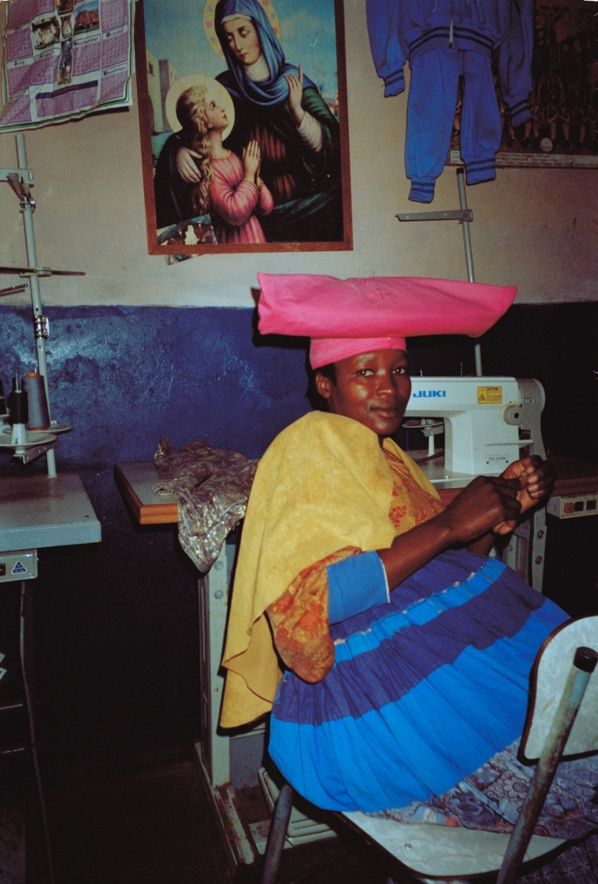
Figure 9 – A dressmaker in the workshop of Itah Hikwama in Mabadutsane, Maun. Photo by the author, 2000. Courtesy Pitt Rivers Museum, University of Oxford [PRM 2009.168.297].

Many inhabitants of Mabudutsane openly discussed their belief that the authorities intended to remove them from the town to locations further away on the periphery, where only fenced plots with nuclear families would be allowed by the town’s Land Board. Many argued that this was proof of their marginal status as a group, and it was evident that many felt bound together by such possibility of potential exclusion at the time. However, it is clear now, some twenty years on, that this was an unfounded fear and that their occupation of this area of Maun continues today, as Figure 8 shows. Two women once became very angry when recounting that they had been told to remove their head-dresses for a photograph required for their national identity (Omang) card, believing that it was a Tswana attempt to oppress them, by removing representations of their culture in official documentation. The government report of 1991 concerning sanitation concerns in the ward, referenced earlier, in fact did not propose wholesale removal of inhabitants but recommended that ‘the area be de-congested to allow developments to be carried out … the decision of individual households to move should be achieved through persuasion not coercion. It must be remembered that there is already some suspicion in the Herero community that the purpose of the exercise is to remove them from the village centre’ (Malila 1991:8). However, given Botswana’s track record of ‘persuading’ minority groups to adopt different modes of settlement, such misgivings were arguably not misplaced. ‘We do not feel secure living here’, stated one Mbanderu man, ‘since we may be moved any time. We do not feel like investing in houses or anything here, since we may be told to leave tomorrow’. Whilst similar sanitation projects were openly discussed in other parts of Maun, people continued to invest time and money in building since they had been told that cash compensation would be paid to all Land Board permit holders. Few in Mabudutsane owned such official Land Board permits, and few trusted that the government would compensate them is removed. The coping strategies of historical displacement were still current within Mbanderu social and material life. Algamor noted that one of the main reasons for Mbanderu reluctance to invest in boreholes was a widespread belief that their stay in Botswana was temporary, and that ‘you cannot take a bore-hole to Namibia’ (1980: 49). In this way both social and material relations were deeply involved in the constant negotiation of group identity over time, and the social relationship to specific landscapes. In Mabudutsane, Mbanderu children experienced social space as a communal and corporate sphere of activity produced by the way building activities expressed and reproduced dwelling relationships among the group. Over time, the socio-spatial communality of their built environment can be seen as a crucially influential factor in the way learned dispositions arose and the way social activities were reproduced.
Of particular interest is the complex way in which marginality and the extended structures of displacement are mutually reproduced over time in specific settlement contexts. In Mabudutsane, the lack of spatial markers as boundaries, the materiality of building and other social activities, and significantly the overt contrasts in homestead arrangement and organisation between village and ohambo contexts, were all influential in producing and reproducing sets of social activities that confirmed their own narratives of cultural difference. For instance, the importance of cattle-based activities for many families meant that time and mutual social involvement were located at the ohambo, whereas only infrequent activities were located in Mabudutsane where they stayed in a house within an extended kin area. The material and socio-spatial attributes of Mabudutsane were often consciously reflected upon by people as revealing that they were not ‘village people’ but pastoralists, and did not ‘know’ how to settle in villages. This reflection was further politicised as evidence of group difference and marginality. More importantly however, the lasting and transposable dispositions, or habitus, of displacement and marginality, can be seen as having had an important material involvement in the way settlement contexts operated as locales for learning sociality. As ‘a subjective but not individual system of internalised structures, schemes of perception, conception, and action common to all members of the same group’ (Bourdieu 1977: 86), the habitus of dwelling practices in Mabadutsane had its roots in the pastoral life discussed earlier, but which found different forms and strategies in a town in a country that many Mbanderu still did not feel settled in.

Conclusion

Mabadutsane was a place of other places, its houses, pathways and meeting areas were forms of a wider social landscape. The social and material biographies discussed in this paper suggest a relationship to landscape in which multiple connections to differing locations are highly desirable for many displaced and migrant groups such as the Mbanderu. This notion is expressed in the Mbanderu concept of ekondua rimue, which makes possible pastoral movement and flexibility through complex sets of reciprocal social relationships within both patriclan and matriclan groups and affinal relations. Although it has a conceptual dimension, ekondua rimue should really be understood as the various sets of material practices engaged in by people, such as cattle-keeping and village contexts, and the way in which Mbanderu go about dwelling across such contexts. Building relations within the onganda set out spatial relationships, and these spatial relations are also expressions of a family’s kin relations. Practices of homestead creation through marriage, birth, and eventually death, are also processes that convert homesteads into burial places, prompting movement once again. Material and social practices of settlement join across the ekondua rimue to create the social landscape. Central to this analysis of dwelling has been the presence of place as process rather than site, as in the understanding of social production and reproduction. Most Mbanderu asserted that visiting relatives in other places was integral to their dwelling in the landscape, one person even comparing the social trails of visiting as the veins along which blood flowed within the extended family’s body. The total set of relationships between these metaphorical ‘bodies’ over time may well come close to how ekondua rimue should be understood both as an abstract social concept and as an involved and engaged manner of dwelling in the world. My argument in this paper has been that whilst contexts of identity are continually evolving, the making of dwelling places are integrally involved in such processes, and that the material practices of dwelling in Mabadutsane could be understood as dynamically involved in processes of producing and reproducing Mbanderu senses of ‘permanent temporariness’ and marginality within Botswana.

Bibliography

Almagor, Uri 1980. Pastoral identity and reluctance to change: the Mbanderu of Ngamiland, Journal of African Law, 35-61. doi:10.1017/S0021855300008846

Blier, Suzanne Preston 1987. The anatomy of architecture: ontology and metaphor in Batammaliba architectural expression, Cambridge: Cambridge University Press.

Bourdieu, Pierre 1977. Outline of a theory of practice, Cambridge: Cambridge University Press.

Carsten, Janet and Stephen Hugh-Jones (eds.) 1995. About the house: Lévi-Strauss and beyond, Cambridge: Cambridge University Press.

Casey, Edward S. 1996. How to get from space to place in a fairly short stretch of time: phenomenological prolegomena, in Feld, S. & K. Basso (eds.), Senses of Place, Santa Fe: USA.

Ekwensi, Cyprian 1962. Burning grass, London, Heinemann.

Evans-Pritchard, E. E. 1940. The Nuer: a description of the modes of livelihood and political institutions of a Nilotic people, Oxford: Clarendon Press.

Harvey, David 1992. Justice, nature and the geography of difference, Oxford: Blackwell.

Heywood, A, Lau, B, and R. Ohly (eds.) 1992. Warriors, sages and outcasts in the Namibian past, Windhoek (Namibia): Michael Scott Oral Records Project.

Ingold, Tim 1993. The temporality of the landscape, World Archaeology, 25/2, 152-73. doi: 10.1080/00438243.1993.9980235

Kandapaera, Kaendee ua 1992. War, flight, asylum: a brief history of the Ovambanderu of Ngamiland, Botswana, 1896-1961, University of Botswana: Unpublished B.Ed. Thesis.

Lemonnier, Pierre 2012. Mundane objects: materiality and non-verbal communication, Walnut Creek (CA): Left Coast Press.

Malila, Ikanyeng 1991. Maun socio-economic and housing study: Mabudutsa and Mabudutsane wards, Gaborone: Ministry of Local Govt. & Lands.

Moore, Henrietta 1986. Space, text and gender: an anthropological study of the Marakwet of Kenya, Cambridge: Cambridge University Press.

Morton, Barry 1994. Servitude, slave trading, and slavery in the Kalahari, in Elizabeth A. Eldredge and Fred Morton (eds.), Slavery in South Africa, 215-250. London: Routledge.

Morton, Christopher 2002. Dwelling and building in Ngamiland, northern Botswana, Oxford: DPhil thesis.

Morton, Christopher 2007. Remembering the house: memory and materiality in northern Botswana, Journal of Material Culture, 12/2, 157–79. doi:10.1177/1359183507078123.

Morton, Christopher 2004. Fixity and fluidity: chiefly authority and settlement movement in colonial Botswana, History and Anthropology, 15/4, 345–65. doi:10.1080/0275720042000298688.

Parkin, David 1999. Mementoes as transitional objects in human displacement, Journal of Material Culture, 4/3, 303-20. doi:10.1177/135918359900400304

Pennington, H. and R. Harpending 1991. How many refugees were there? History and population change among the Herero and Mbanderu of Northwestern Botswana, Botswana Notes and Records, 23/1, 209-221.

Vivelo, Frank R. 1977. The Herero of western Botswana: aspects of change in a group of Bantu-speaking cattle herders, St. Paul, USA: West Publications.

Yamba, C Bawa 1995. Permanent pilgrims, Oxford: Oxford University Press.

This work is copyright of the author. Readers should note that the images are NOT included under the CC-license, but attributed to the rightful copyright owner.

It has been published by JASO under a Creative Commons Attribution-NonCommercial-ShareAlike License (CC BY NC 4.0) that allows others to share the work with an acknowledgement of the work's authorship and initial publication in this journal as long as it is non-commercial and that those using the work must agree to distribute it under the same license as the original. http://creativecommons.org/licenses/by/4.0/)

Head of Curatorial, Research and Teaching and Associate Professor, Pitt Rivers Museum, University of Oxford, UK. E-mail: christopher.morton@prm.ox.ac.uk
Fieldwork was carried out in 1999-2000 during an attachment as Research Fellow in the Department of Sociology, University of Botswana, and as a research student at St Antony’s College, Oxford, where this data was originally submitted as part of my wider DPhil thesis on settlement practices in Ngamiland (Morton 2002). The support of the ESRC is gratefully acknowledged (grant no. R00429834578).
The Tawana are a Tswana subgroup who split off from the Kwena subgroup and migrated north to Ngamiland around 1800.
For a discussion of the history of batlhanka as servants or enslaved persons in the Kalahari region, see B. Morton 1994.
I was told that this leader was junior in authority however to a senior leader who remained in Namibia.
It was suggested to me on several occasions by Tswana informants that the significance of facing west in Mbanderu and Herero culture could be understood if one considered that they were facing the direction of their homelands in Namibia, and that the dead were buried facing toward their ancestors there. No Mbanderu would confirm this however, arguing that it was simply an inherited cultural practice (ombazo). Herero oral historical data from Namibia does tend to corroborate this. In the collection of oral histories and stories, Warriors, Sages and Outcasts in the Namibian Past (Heywood et al. 1992), Kaputu relates that, ‘in those days the houses of the Hereros were built in a circle within an enclosure with four gates. One afternoon a baboon came into the homestead from the west ... then walked between the holy fire and the kraal, and from there it walked past the door of the main house of the holy fire to the eastern gate’ (1992:62). The description of the baboon’s movement suggests that the homesteads of pre-displaced Herero and Mbanderu in Namibia corresponded very closely to those found in Ngamiland, as noted by Vivelo (1977).
If the first wife only had daughters, a second wife would still build to the left where sons normally build.
Birds mostly build nests in on the westerly side of Acacia trees to avoid the intense heat of the day, and some Mbanderu suggested to me that doors were faced west since people wanted to ensure that the entrance to doorways, where people often sit, was likewise kept shaded.
Google street view data used to assess this comes from 2012, which showed even then a marked increase in investment in concrete block mantlo a sekgoa, or European-style building.
The detailed plan is available for consultation in the Pitt Rivers Museum Manuscript Collections, Morton Papers, Box 2.
Map sources: (left) Dept of Surveys and Mapping, Government of Botswana, 1994 (Sheet 0943) Based upon 1994 aerial photography; (right) Google Maps. ‘Maun, Botswana.’ Satellite image. 2022, https://www.google.co.uk/maps/place/Maun,+Botswana/@-19.998701,23.4197523,728m Accessed 20 July 2022.

