SPATIAL CHANGES IN AN OXFORD PUBLIC ASYLUM
YUXIN PENG

Abstract
This article examines spatial changes at Littlemore hospital in Oxford between 1846 and 1956, the period since its foundation as a Victorian public asylum to the very last years before a radical psychiatric reform was implemented. I propose to see the asylum and later hospital spaces of Littlemore as being bodily sensed and co-productive with social processes. Specifically, I discuss the entanglement of these spaces with three factors: (panoptical) control, considerations of cost, and residents’ comfort. With emphases on residents’ bodily well-being and experiences, I aim to present a dynamic account of this part of the history of institutionalized mental health.

Introduction
Existing anthropological literature on mental health in public institutions has a strong interest in power. As noted by Lorna Rhodes in her ethnography of maximum-security prisons in the USA, although she does not see her project as ‘an application of Foucault to prisons’, she has found it impossible not to address the distinction between reason and madness and the phenomenon of panoptical observation (Rhodes 2004: 15). Regarding the specificity of her research topic, which is about severe mental health in the most secure prisons in America, an orientation towards these themes is both reasonable and suitable.
Rhodes’ later work on psychiatric citizenship looks at it from the inmate’s perspective. By analysing the interviews, letters, poems, and drawings she obtained from Sam, an inmate whose mental health worsened in this supermax prison, Rhodes discusses how psychiatric citizenship is formed in a strictly controlled institutional setting by one’s attachment to a psychological report made on one’s case, which also led Sam to a new way of making sense of his own history (Rhodes 2010). This perspective is perhaps both more nuanced and slightly more ‘hopeful’ compared to a mere focus on panoptical observation when analysing mental health in prisons. Nevertheless, the theoretical framework adopted by Rhodes still falls within a broader Foucauldian tradition, namely that of biopower and biopolitics (e.g., Rose 2001, Rabinow and Rose 2006).
The Foucauldian tradition is not the only one that examines mental health in public institutions from the point of view of power. There is also Nancy Scheper-Hughes and Anne Lovell’s introduction (1987) to medical anthropology that revolves around the essays of the Italian psychiatrist and reformist, Franco Basaglia. Their introduction to these essays is based on a review of the anti-psychiatry movement in Italy from the theoretical framework of the political economy of health (PEH). Scheper-Hughes and Lovell explore how Basaglia was influenced by Marxism, specifically the works of François Tosquelles, Antonio Gramsci, and Jean-Paul Sartre.
Furthermore, the authors introduce Basaglia’s own critique of asylums, which was arguably more radical than the Foucauldian framework mentioned above. The movement that Basaglia launched from a provincial asylum in Gorizia, northern Italy, between 1961 and 1969 is called democratic psychiatry (psichiatria democratica). Helped by new anti-psychotic medications developed in the 1950s, the democratic psychiatry movement has eliminated all forms of violent physical constraints that are common in asylums. Instead, meetings (assemblea) are organised for the patients’ free expressions of ‘anger, passion, and unreason’, which are not acted on by any member of staff or interpreted by any doctor from the perspective of psychoanalysis. According to Scheper-Hughes and Lovell, the aim of organizing these meetings is to challenge the ‘underlying structure of power relations’ directly, the ultimate aim of the movement being to shut down all the asylums in Italy (ibid.: 27).
Basaglia’s influence has also been profound on social research into psychiatric movements. His work has been discussed, for instance, by Helen Spandler (2006) in her book on the therapeutic community at Paddington Day Hospital, and by Nick Crossley (2006) in his analysis of anti-psychiatry in the UK. Besides, Basaglia’s movement has also had a direct social impact, as it led to the Italian Mental Health Act of 1978 (also known as the Basaglia Law or Law 180) and influenced many similar movements initiated in Brazil, Mozambique, and the US (Pandolfi and Bibeau [2005] 2007).
However, a focus on power may arguably not capture the multiple developments in psychiatric history, such as the deviation of some public asylums from the panopticon prison prototype. Indeed, although many asylums constructed in the seventeenth century adopted the radial layout of the prison, as we shall see later, many public asylums constructed since the early nineteenth century turned to a more humane alternative.
Moreover, public asylums and many other mental-health institutions are often investigated from an atemporal perspective, being somewhat ‘frozen’ for a focused analysis of their internal organizations, even when the latter are in a process of radical reform. However, the spaces of a mental-health institution actually appear as more changeable if viewed over a longer period of time. These subtle changes are often reflected in architectural and spatial alternations, such as the choice of a new layout, the placing of an additional building block and some even smaller material changes during a refurbishment. A public mental-health institution, viewed through the prism of its architectural and spatial changes, is therefore an ever-changing place entangled in social processes. This makes it more hybrid and complex than a mere withholder or representation of power.
The aim of this article is thus to examine spatial changes at Littlemore hospital between 1846 and 1956, from the time of its foundation as a public asylum until the very last years before an organisational reform was implemented. I credit part of my approach to Elisabeth Hsu’s work (2005) on how time is inscribed in space, which means that the spaces discussed in this article are not only representational and socially produced, but also co-productive with social processes. In addition, I am also inspired by the papers of Kathryn Cassidy, Jong-Min Jeong, and Paola Juan presented at the 2020 RAI annual conference (also Jeong 2020; Cassidy et al. 2020). Their work shows how research on mental-health institutions can go beyond the power discourse to focus on other important themes, such as care, materiality, memory, imagination, intimacy, and alterity. A newly published paper by Natassia Brenman (2020) on how precarity is ‘placed’ in immigrants’ access and transition in a London mental-health charity is also relevant, as we share the same aim of seeing a health landscape, with its own materiality, as shifting and as altering dynamically through time.
This is not to say, however, that this article is not concerned about issues related to power: these dominant themes remain unavoidable. Rather, my attempt is to emphasise residents’ bodily well-being and experiences by adding another two dimensions – the cost of architectural constructions and residents’ comfort – to my research into a Victorian asylum in Oxford. I argue that, by including these aspects, spaces in this public mental-health institution can be seen as more dynamic and changeable.
Methodologically, I have worked with archival images displayed on the Picture Oxon website created by Oxfordshire County Council in collaboration with the Oxfordshire Health Archives, the Oxfordshire History Centre, and others. By browsing with the keyword ‘Littlemore’ (the site of the asylum and later hospital) with decades selected between 1840-1999 on the website, I have been able to examine 68 photographs that are available online. The themes of these photographs are very intriguing and diverse, including a diet sheet from 1854, a case book from 1852, an admissions certificate for a patient called George from 1880, and aerial views of the hospital in different years. However, my focus here emphasises Littlemore’s spatial and architectural details. Apart from the archival images from Picture Oxon, the websites ‘Asylum Projects’ and ‘County Asylums’ have also been extremely helpful because they provide many factual details about asylum architecture in the UK in the nineteenth and twentieth centuries.
As Sarah Pink (2001) notes, when looking at archival photographs, my own gaze as an ‘interviewer’ of images informs my anthropological inquiry into spatial changes. I am aware that visual images, when produced, will intrinsically bear the perspectives of the photographers and that they are selected to be stored in different types of archive (e.g., a health archive, a regional archive). For some of the images mentioned in this article, my gaze may divert from the gazes of photographers, reflecting a suggestion in the anthropology of archives that subversive analysis of materials from the past may disclose novel insights for present and future research (Zeitlyn 2012). Specifically, my analysis of archival photographs is based on picture-reading methods introduced by Marcus Banks and David Zeitlyn (2015). This means that I will not only look at the contents of photographs, but will also analyse the supplementary information about them, such as titles, years of production and descriptions. This side information often indicates the ‘orthodox’ themes focused on by photographers and archivists, which my gaze may not always follow. Being aware of these ‘orthodox’ themes, I will also pay attention to the marginalized items which contain key information about spatial changes.

Sensitivity to comfort: from radial layout to corridor plan
Originally known as the Oxford County Pauper Lunatic Asylum, Littlemore Hospital was constructed in 1841 and opened on 1 August 1846. As mentioned in the Oxfordshire Health Archives, it was one of the earliest public asylums to be constructed after the 1845 Lunacy Act, the legal document which gave local authorities the responsibility for creating suitable institutions for people living with mental illness.
When the Commissioners in Lunacy gathered to work out the guidelines for local authorities to build their own county asylums after the 1845 Lunacy Act, they picked up the proposal made by the Quaker mental-health reformer Samuel Tuke (1784-1857) for the Retreat at York to keep public asylums small in size, with no more than three hundred beds. They also emphasised the provision of airy and healthy living environments for residents in purpose-built public asylums (Taylor 1991: 134). This concern for asylum residents’ living experiences in the early nineteenth century was enacted through the emergence and spread of ‘moral treatment’, a series of therapeutic reforms initiated from the last decades of the eighteenth century by Philippe Pinel, Samuel Tuke, and other activists for the alleviation of physical restraints and the provision of humane treatments in asylums (Bynum 1981).
While researching the birth of asylums in Madness and Civilization, Michel Foucault read Tuke’s book and described how the moral treatment used at The Retreat transferred the terrors of madness from prison-like physical constraints to the ‘seals’ of conscience (Foucault [1961] 2001: 234-5). Apart from his distinction between reason and madness, Tuke’s argument for the superiority of moral over medical treatments is also seen by medical sociologists and historians as a ‘rather damning attack on the medical profession's ability to deal with mental illness’ in the late eighteenth century (Bynum 1981: 43). Resting on psycho-social interventions, the reforms of ‘moral treatment’ challenged late eighteenth-century physicians who just became interested in the world of the insane. This world was considered to be originally dominated by the Hellenic humoral tradition, but was joined by late eighteenth-century physicians who adopted a Cartesian framework asserting an entire somatic basis for mental disease (Scull 1981: 7-8).
Despite the challenge to their professions, the significance of Tuke’s moral treatments was recognized by many pragmatic physicians in the nineteenth century, although they did not abandon their own medical treatments, despite accepting the theories and practices of the moral treatment (Bynum 1981: 44). Apart from these theories and practices, the architectural layout of the Retreat at York was also advocated by many early nineteenth-century psychiatrists and asylum architects as a prototypical ‘moral architecture’ for purpose-built public asylums (Scull 1989). The prototypical architectural layout of The Retreat was known as the ‘corridor plan’, and it was adopted by the Oxford county asylum (Littlemore hospital), Nottingham asylum, Lancaster asylum, Wakefield asylum, London Hanwell asylum, and others (Taylor 1991). Potentially following the advice of Tuke and the Commissioners of Lunacy on the proper size of an asylum, the Nottingham architect Robert N. Clark limited the size of Littlemore to 120 beds (Yorston and Haw 2005).
Floorplans of The Retreat are displayed on pages 95 and 102 of Samuel Tuke’s book, published in 1813. Patient bedrooms were situated along a long corridor, at the centre of which were communal areas and staff bedrooms. There was a clear separation of the sexes: the ground floor had bedrooms for male patients only, while the bedrooms on the floor above were mainly for females, except for one gallery at the east end. The large area in front of the building for outdoor activities was also divided into male courts and female courts by a long central pathway. Apparently, The Retreat had a very small corridor plan: by the time Tuke wrote his book, it had only 24 male and 38 female patients (Tuke 1813: 96).
John Conolly (1847), a psychiatrist at London Hanwell Asylum, embraced the corridor plan in his book with pieces of advice for purpose-built public asylums after the 1845 Lunacy Act. Opened in 1831 with three hundred beds, the Hanwell Asylum was designed by a Quaker architect, William Anderson, who claimed to have been influenced by Tuke (Taylor 1991: 134). The asylum therefore adopted a similar layout to that of The Retreat, and was seen as one of the earliest corridor-plan public asylums. Besides advantages for medical supervision from the centre of a corridor, Conolly argued that the plan also made asylum life more comfortable because the long and narrow building had better ventilation and more natural light. As he vividly noted:
It is evident that a building of this shape, long and narrow, consisting of a succession of galleries or corridors, with bedrooms on one side only, may be moderately perflated by every wind that blows – an advantage extremely salutary to those who pass their whole time in it. The want of proper ventilation is chiefly incidental to the angles of the building, and to the centre, and should be carefully provided against. In hot climates, exposure to sun is a frequent cause of cerebral excitement, and many of our patients persist in exposing their bare heads to the sun in the hottest weather, until it is scarcely possible to touch their heads with one’s hand. But in this country the hot season is of short duration, and it is especially necessary to consider that no gallery within the house, and no airing-ground exterior to it, should be deprived of some shares of sunshine in the winter, as well as of free access of air, and some shade in summer. Quadrangular buildings, (unless the quadrangle is very large, and the buildings are very low,) and circular buildings, and central towers or crescents with radiating wings in three or more directions, are open to great objections on every account. (Conolly 1847: 12-13)

Conolly recommended the corridor layout to deal with two environmental factors: wind and sunlight. Wind that ventilates could easily blow through the long and narrow building, and there was also sufficient sunlight to generate heat and light. As an advocate of moral treatment and moral architecture, but one whose medical training was still somewhat influenced by the humoral tradition, Conolly’s proposal for better ventilation and natural light is reasonable. However, as a sensory medical anthropologist I find his account intriguing in another way: as an asylum psychiatrist, Conolly observed how the residents enjoy sunbathing, and felt their excitement and joy. He might have genuinely touched some patients’ heads to feel the heat, an observation perhaps leading to some real physical interactions. Through his account, the imaginative reader may feel somewhat brought back to the place herself. And as Constance Classen (2017) shows in her multisensory historical accounts of how people engaged with museum objects in the past, the reader may tend to experience the fresh air and heat that Victorian asylum residents experienced through a psychiatrist writing in 1847.
Conolly also compared different asylum layouts. As he argued in the last sentence in the extract above, he strongly opposed quadrangular, circular, and radial layouts, which no doubt would have been read at the time as a critique of Jeremy Bentham. The radial plan was believed to have its roots in Bentham’s panopticon prison of 1791, and it was adopted in Glasgow, Cornwall (Bodmin), Gloucester and Devonshire. The nineteenth-century asylum architect Charles Fowler commented that, in a radial plan asylum, ‘the whole and every part and every person is continually under the eye of the Governor or his assistant’ (Fowler, quoted in Taylor 1991: 137). Jeremy Taylor also notes in his book that cost and supervisory efficiency alone made the radial plan popular before 1845. He therefore sees the proposal for a corridor plan made by early nineteenth-century psychiatrists, commissioners, and asylum architects as a ‘humane’ turn in the history of asylum architecture (Taylor 1991: 135).
To better compare the living conditions in asylums built with corridor and radial layouts respectively, I will now look specifically at the building plans for the Oxfordshire county asylum (Littlemore hospital) and Devonshire county asylum (Exminster hospital, near Exeter). While Littlemore adopted the corridor plan, Exminster’s plan was radial.
Like the Retreat at York and London Hanwell, the main building at Littlemore was long and narrow. A three-storey central administrative block was placed between two flanking octagonal supervisory hubs, each hub overlooking three building blocks with patient dormitories. These hubs indicated that supervisory efficiency remained one of the asylum architects’ initial concerns. Moreover, the panoptical form of control was retained in the corridor layout, although the latter was seen as a humane turn to improve the living conditions of the asylum’s residents. In addition, the sexes were separated, as at The Retreat: female dormitories were arranged in the south of the administrative block, the male ones in the north. There were only 120 beds when the asylum was opened in 1846 (Lobel 1957).
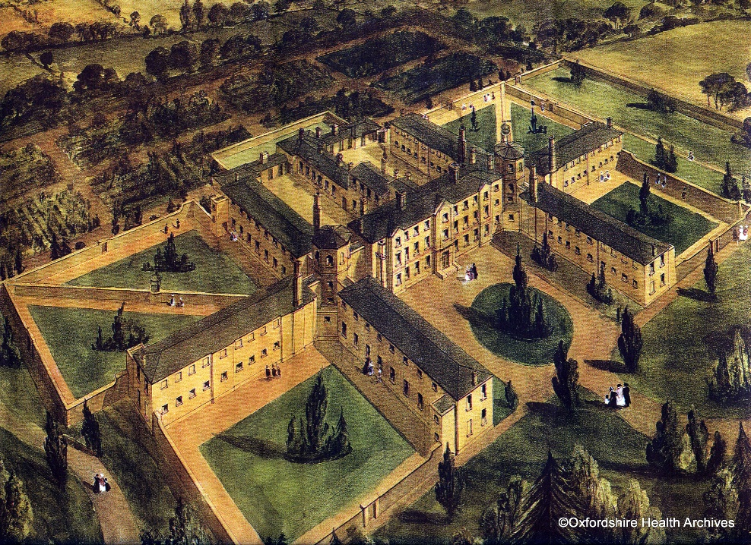
Fig. 1. Painting of Littlemore hospital in 1845, Oxfordshire Health Archives. Used with permission.

The Exminster Asylum designed by Charles Fowler, on the other hand, was opened in 1845 with 450 beds (Taylor 1991). It had its administrative hub in the centre of a semi-circular three-storey ‘range’, a term used by architectural historians to describe a long building or row of buildings. The residents’ dormitories were arranged on six radiated blocks around the range. As noted by Fowler, these blocks were allocated respectively for patients from different classes (see Taylor 1991: 137). The sexes also seem to be separated, as the Asylum Projects website records that the service area or day room at the end of each block was arranged ‘by gender’.
Taylor (1991) notes that the Exminster asylum was an improved version of the classic radial plan because the old circular and enclosed design was cut into a semi-circular shape with a long building stationed between the central administrative hub and the radiating blocks. This change facilitated deliveries of food and medical supplies while preserving the essential idea of Bentham’s panopticon prisons (Taylor 1991: 137). However, the residents’ well-being and experiences with regard to allowing ventilation and transparency of natural light remained unimproved, and the asylum was criticised by the Commissioners in Lunacy in their 1844 report as not so different from the classic radial plan (ibid.).
Following Conolly’s emphasis on ventilation and natural light as influencing the residents’ well-being and experiences of the asylum, I have taken screenshots on Google Maps of the old sites of the two asylums today to further demonstrate the differences. The shots have been taken on the same computer on the same day with the same zooming scale (twenty metres before fitting to this page). Littlemore in its original layout did not contain the buildings coloured red in Fig. 2, while Exminster today, depicted in Fig. 3, remains almost the same as its original (see painting referenced in footnote 9).

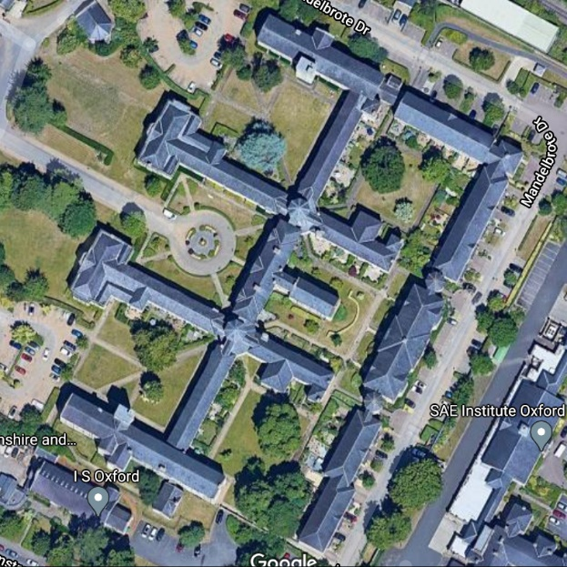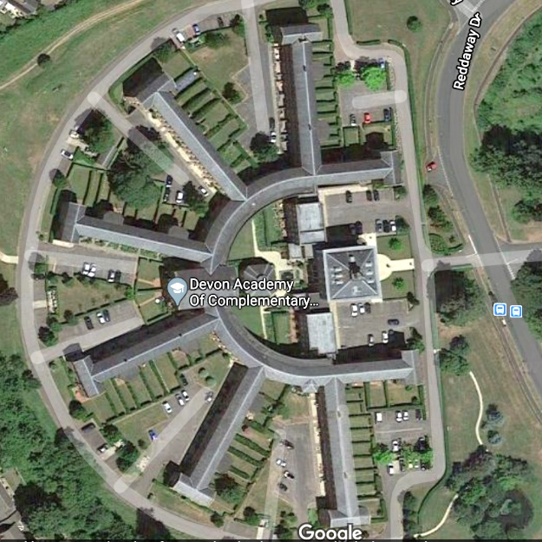
Un-built
in 1846
Figs. 2 & 3. Littlemore (left) and Exminster (right) on Google Maps, taken 19 October 2020

At first sight, the sunlight should reach more blocks at Littlemore because they are arranged in a line, while the semi-circular range and the densely built buildings of Exminster would each block out the light of the other. Ventilation must have been somewhat similarly affected: Littlemore, with its long, thin, vertical layout, should have been better ventilated than the round-shaped Exminster. Moreover, fewer blocks at Littlemore left more green spaces. The vista from the windows of most Littlemore blocks should also be wider than that provided by the dense blocks of Exminster.
A comparison aided by the online maps, allowing one to speculate how people in the past sensed the place, may also contain the potential for anthropological research. Although textual materials are often helpful, as used by Classen (2017) in her research on use of the senses in museums, here I propose another method which relies on certain environmental factors that have lasted long enough to be considered continuous from the past to the present. The climatic conditions of wind and sunlight in the UK, for instance, may not have changed very much from Victorian times. Likewise, the building blocks of Littlemore and Exminster have been preserved and are available for an aerial view. Combing the two environmental factors (i.e., wind and sunlight) with preserved historical sites may therefore help a sensory medical anthropologist compare the degrees of comfort experienced by asylum residents in the nineteenth century.
In summary, the initial design of Littlemore, together with that of many other public asylums established between 1808 and 1845, adopted the corridor plan layout, which provided a more comfortable living environment. In contrast, the efficiency and supervision-centred radial layout based on the panopticon prison was disfavoured by many Victorian psychiatrists and architects like Conolly and Taylor. Although surveillance and panoptical control can still be found on the supervisory hubs of most corridor-plan asylums, the proposal for such ‘moral architecture’ still marks a humane turn in the history of public asylums.

Spatial changes in extensions: increasing consideration of the cost
Ever since its establishment in 1846, Littlemore had been faced with increasing pressure to accommodate more residents. Despite the 1845 Lunacy Act, not all counties in England were able to build their own public asylums. For example, Berkshire contracted with Oxfordshire to accommodate its residents living with mental illness at Littlemore in order to meet the legal requirement. A new building programme was then commenced in 1848 to enlarge the asylum. As recorded on the website of County Asylums, this new project was initiated by Oxford architect Henry Jones Underwood in 1848 and finished by John Chessell Buckler in 1852. A three-storey block and a tower with a water tank were added to the northern and southern extremities respectively of the original corridor-plan building, built in 1846.
Although only one block was added on each side of the end of the corridor in this extension, the benefits of ventilation and natural lighting in the original layout were reduced because new buildings at the two extremities would block some wind and sunlight that formally would have reached the old blocks from the side.
At the beginning of the second half of the nineteenth century, the pressure on Littlemore to be enlarged to accommodate more residents increased severely because the country had entered an age of the mass institutionalization of people living with mental illness. Andrew Scull sees in this shift from domestic towards institutional modes of management a ‘quasi-automatic response to the realities of life in an urban-industrial society’, an indication that the problems accompanying the Industrial Revolution could no longer be handled within a household- and community-based relief system (Scull 1981: 216). Eventually, public asylums constructed and enlarged in the late nineteenth century turned into long-term accommodation of those who could not afford private health care for their mental illness (Taylor 1991: 142).
Between 1849 and 1909, the number of borough and county asylums in England and Wales jumped from 21 to 97, and the total number of inpatients increased from 350,000 to 1,008,000 (Taylor 1991: 155). As a result, public asylums with fewer than three hundred beds, originally following the advice of Samuel Tuke, were no longer large enough. Since the 1860s, new architectural layouts with at least a thousand beds were designed, such as the pavilion plan and echelon plan.
In comparison to the new county asylums, built with more than a thousand beds in the late nineteenth century, Littlemore and other corridor-plan asylums, such as London Hanwell, were faced with pressure to enlarge their patient numbers. Between 1848-1900, residents at Littlemore only increased from 200 to 543 (Lobel 1957), which was far less than the new public asylums constructed after 1960. Another extension programme was thus initiated to enlarge the space at Littlemore even more.
On this occasion, the extension programme lasted from 1898 to 1902 and was led by the Oxford architect Henry James Tollit [1835–1904]. As shown in a manuscript drawn by Tollit, a few auxiliary sheds, two single-sex pavilion blocks and a recreation hall were added on the southeast of the original buildings. The County Asylum website (see link in footnote 11) notes that the land for this extension was originally a burial ground but was purchased and filled in.
The 1898-1902 extension further reduced the advantages of the corridor plan in respect of ventilation and natural lighting because the southeast side of the old blocks were attached to the many new buildings in the new extension. In some areas, buildings started to form squares and semi-squares, contrary to Conolly’s original opposition to rectangular layouts. The air in these areas would be therefore become stuck within the enclosed spaces, and the buildings would block each other’s sunlight. When the project was finished in 1902, another two hundred beds were added, enabling Littlemore asylum to house more than eight hundred residents (Lobel 1957).
It can be concluded that the two projects to increase patient numbers at Littlemore no longer emphasised residents’ comfort as much as the original corridor plan did when the asylum was established. Rather, consideration of the cost was increasingly emphasised. For local authorities in the era of institutionalization, the budget would be one key issue to be considered. This is reflected in the change of building materials during the extensions at Littlemore. While the 1848-1852 project used the same ‘squared coursed limestone’ as the original corridor-plan building, the 1898-1902 extension turned to cheaper alternatives: the pavilion blocks on the burial ground were built from yellow bricks, as recorded in the County Asylum.
Increasing consideration of the cost is also reflected in a post-fire refurbishment. After a destructive fire in 1895, the original roofs on the female blocks of the old corridor-plan building were completely removed, and the refurbishment abandoned the old design for a simpler alternative. This difference can be found on the old site of Littlemore hospital today: while the overhanging eaves can still be seen on the shallow-pitched Welsh slate roofs on the male blocks in the north, the refurbished female blocks on the other side no longer have the same characteristic decoration.
In summary, between 1848 and 1902, two building projects were initiated to enlarge Littlemore asylum so it could take more residents. However, these projects no longer emphasised people’s well-being and comfort as much as the original corridor-plan layout did. Rather, the concern for cost increased, as was reflected in the changes to building materials and designs during the asylum’s extension and refurbishment.

Entanglements and the paradox of the windows
The first section above showed how public asylum residents’ well-being and experiences were emphasised in the corridor-plan layout newly proposed in the early 19th century, as opposed to the prison-alike radial prototype. The second section then described how cost considerations compromised the original advantages of the corridor-plan layout in the mid- and late 19th century by intermingling the good quality structures with new building blocks of cheaper materials and simpler design.
While spatial changes to the building structures above have been presented in chronological order by means of identifiable examples highlighting the relations between cost, comfort, and control, the aim of this third and final section is to discuss one single but rather complex case where the three dimensions find expression in the shape and size of different windows in Littlemore’s building blocks.
In this section, I will look at the windows in Littlemore buildings that were put in in different years and discuss how the three dimensions I emphasise – cost, comfort, and control – are paradoxically related to the differences between these windows. Specifically, I will compare windows in the Victorian building blocks constructed before 1902 with those in the new wards built in the 1950s. While the social and architectural histories of the Victorian blocks have been discussed in the sections above, the latter’s buildings may need an introduction.
Since the early twentieth century, massive county public asylums were found to have severe problems of overcrowding and bad care provision (Fakhoury and Priebe 2007). The term ‘asylum’ was no longer favoured, as it suggested old ways of management that used physical violence, constraints now being conceived as inappropriate for mental health care. Littlemore Asylum therefore changed its name to Littlemore Hospital from 1922.
In the Survey Committee’s 1937 report on mental-health services in Oxford City, Oxfordshire, and Berkshire, the number of patients at Littlemore is given as 880. There was also a superintendent, three medical officers, 92 female nurses, and 65 male nurses (Pinsent 1937: 24). The Oxfordshire Health Archives notes that the large number of inpatients had made individually tailored treatment difficult (Oxfordshire Health Archives; see link in footnote 3). Moreover, the 1937 report and some witness seminar materials on the history of Littlemore all mention complaints that the old asylum buildings were no longer suitable for proper mental health care (e.g., high ceilings producing echoey sounds and voices, hard furnishings, and linoleum floors).
Potentially due to these complaints, the County Asylum website records a third major construction of new building blocks in the 1950s. The project this time included a new admissions and treatment centre, a few more facilities and accommodation for the staff, and a small new site on the other side of the Sandford road opposite the old blocks built in the asylum era. Thanks to a digitalization project initiated by Oxfordshire County Council, Picture Oxon, many photographs of the wards in these new blocks, together with some of the dormitories in the old Victorian building, can be viewed online for a comparison. I therefore arrange the photographs into two groups.
The first group contains two photos of the old Victorian blocks. Fig. 4 below is entitled ‘Male patients and staff’ in Picture Oxon and recorded as having been taken in 1870 outside the original corridor-plan building. It is a group portrait, as its title indicates. In the centre of the image are eleven people. Three, all standing, are in dark staff uniforms. Eight are wearing inmates’ uniforms, some standing, some sitting, and one lying on the ground. These human figures, together with the two cats held by patients sitting on the bench, are mentioned in the description for this photo in the archive.
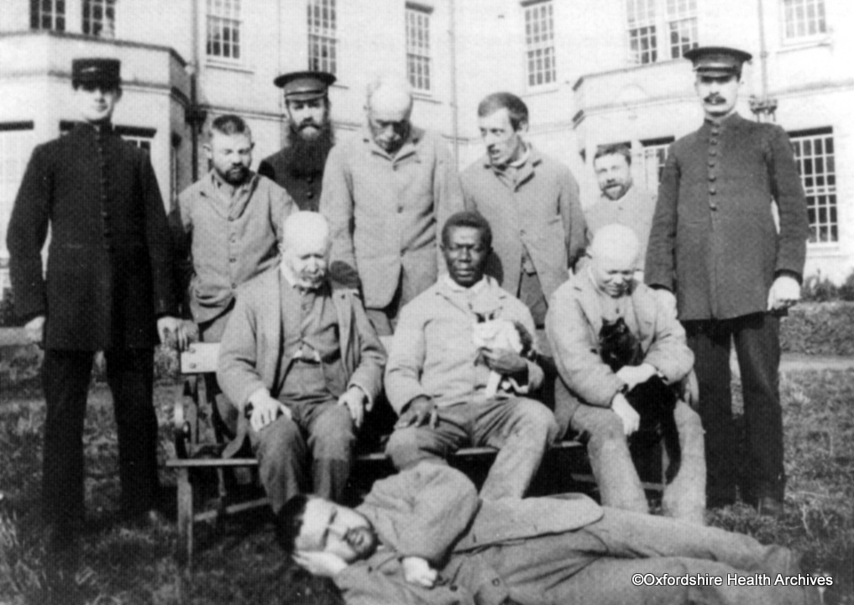
Fig. 4. ‘Male patients and staff’, 1870, Oxfordshire Health Archives. Used with permission.

However, my gaze goes to the windows on the old blocks in the background. These windows are Victorian in style: narrow, multi-paned, with frames painted in white. Some windows are open, with very narrow gaps from the upper sash, which indicates the level of ventilation in the dormitories.
The second photograph is recorded as having been taken in 1924, so it should be either within the corridor-plan building or in one of the pavilion blocks (no further residential blocks for inpatients were found to have been built between 1902 and 1956). This photo is entitled ‘Ward pre-1930’, with no further description. In its centre are five beds, at least two of which are occupied by patients. Vases containing floral ornaments and a picture can be seen on the wall, while a pot of flowers is by the window. A bright light is hanging from the ceiling. None of the windows in this photo appear to be open, but they are similar in style to those in Fig. 4: narrow and multi-paned with white frames.

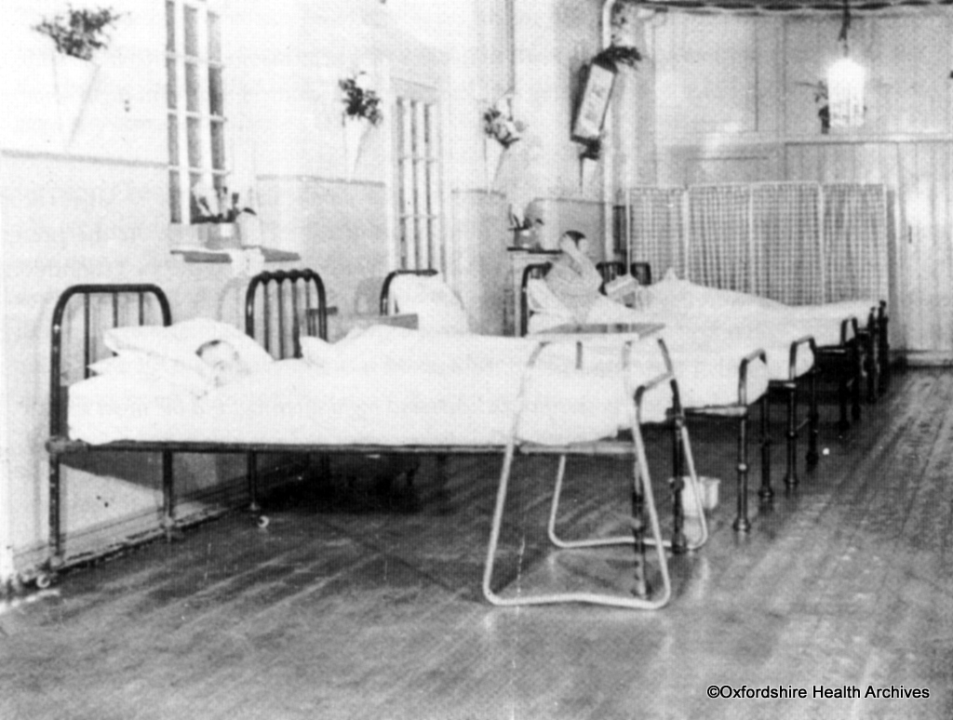
Fig. 5. ‘Ward 1924’, Oxfordshire Health Archives. Used with permission.

The narrow, multi-paned windows are often found in Victorian architecture on public institutions, commercial buildings (e.g. pubs) and private residential housing. Materials for the window frames vary from timber to cast iron. However, when it comes to the design of asylums, security, the control of destructive behaviour, and the prevention of patients escaping were aspects to be considered. Leonard Smith finds that, in nineteenth-century public asylums, windows were often built small and high in cast-iron frames and sometimes protected by iron bars and shutters (Smith 1999: 160-1). John Conolly, in his introduction to the London Hanwell asylum, also mentions cast-iron windows with wire guards. He believes that windows as such ensure no patient can escape. However, he also points out that excessively secured windows may be a hinderance to residents if they have to evacuate the building in a fire, as they would have to wait for the gallery doors to be opened, instead of escaping through the windows (Conolly 1847: 20). The photos above indicate that Littlemore had a similar narrow and multi-paned design in its time as an asylum. The limited opening gap of the windows shown in the photos above also indicates a concern with security and the control of patients.
The information about these Victorian windows may inform an argument made by Leonard Smith (1999), namely that although a more humane impression was generated by the exterior layout, considerations of security and control could still be found in the building’s architectural details. These small and narrow windows on the old blocks of Littlemore hospital again limited the ventilation and natural lighting of the wards, which might be one of the reasons for them to be complained about and considered unsuitable for proper mental healthcare in the 1950s.
In contrast to the windows in the old blocks, the second group of photos show the new wards built in the 1950s. This group of photos is recorded as having been taken by John William Thomas for the Oxford Mail and Times in June 1956. The collection includes photos of the newly built reception, wards, corridors, toilets, recreation rooms, canteen, and kitchen in the new blocks. A few photos of the new wards share the same title and description: ‘Caption as transcribed by Thomas Photos Project, from Thomas's ledgers: Interior view of a ward at Littlemore Hospital’. Unlike the photos in the first group, no human figures are depicted. Instead, there are beds, lockers, lights, tables, chairs, and windows, which can all be seen as essential items in a ward.
Noticeably, the windows of these new blocks appear to be very different from the Victorian ones. The window panes appear to be fewer but much larger and wider. There are no iron bars, shutters, or other earlier forms of protection. Although the degree of ventilation is uncertain, the ward appears to be well lit by sunlight due to the size of the window panes. In one of the photos mentioned in footnote 20 (Picture Oxon reference: POX0267785), a beautiful landscape of a field and farmhouses can be seen from inside the wards, which may be another improvement compared to the limited vista obtained from the narrow, multi-paned windows in the old Victorian blocks.
Although the wards are better lit thanks to the large windowpanes, this radical change of window design should not simply be seen as an improvement compared to the former hospital architecture. It would therefore be a simplification to say that the mental hospital buildings of the 1950s, compared to blocks constructed during the late Victorian era, place a greater emphasis on the residents’ well-being and comfort by changing the design of the ward windows.
Throughout the history of the asylum, windows have been linked to residents’ destructive behaviour and attempts to escape. Objects being thrown to break windows are recorded in both the nineteenth- and twentieth-century literature on public asylums and mental hospitals (Conolly 1897, Mandelbrote 1964). Having windows built high and narrow and with protection is a visible measure to deal with these attempts and behaviour. If, in the 1950s, these protective measurements were removed from the windows, there must have been other ways of keeping such behaviour under control.
I propose one reason that enabled the change of window design, namely the development of the first generation of antipsychotic medication. Chlorpromazine, the first-ever antipsychotic medication, was synthesized in 1950 and marked the beginning of the era of medication. While regarded as a treatment miracle, these first-generation antipsychotics have also been reflected upon by anthropologists in the last century with respect to how they transformed the physical constraints into biomedical control over the body, at the cost of affecting the quality of one’s life (Estroff 1981). In other words, the dimension of control over one’s body remained, but was moved from the building to the medicine. The degree of comfort experienced by an inpatient in the 1950s thus became more difficult to evaluate, and there would be the additional impacts of medication, which were hard to visualise. The change of windows should therefore not be seen merely as another humane turn made in mental health institutions.

Moreover, the change of windows, together with the overall changes in building construction, entail a paradox in relation to the cost. While the old Victorian building blocks were intensively criticized in the mid-twentieth century as unsuitable for proper mental healthcare, eventually leading to the evacuation of residents from the hospital, the private residential housing into which these blocks were converted in 1998 became high-end, luxurious properties.

Conclusion
Seeing asylum and mental hospital spaces from the past as bodily sensed, this article has examined spatial changes at Littlemore between 1846 and 1956. While the good ventilation and natural lighting of Littlemore’s original corridor-plan building, completed in 1846, was compromised by the cost-saving extensions of 1848-1852 and 1898-1902, physical control of the residents remained strong throughout the whole period. These aspects of control were initially found in the supervisory hubs in the corridor-plan buildings and the separation of sexes into different dormitories. Since the mid-twentieth century, when the first-generation of anti-psychotic medications were developed, control of residents’ bodies enacted within the buildings moved to medication, making the social impacts of and on hospital spaces more complex and ambiguous.
Specifically, in this article I emphasise the changes in asylum and subsequently in hospital residents’ experiences over time. I see people in the past with their perceptions of the places they lived in. Some of these perceptions can be reflected in the writings of a few Victorian psychiatrists and architects (e.g., John Conolly), who observed asylum inmates empathetically. Some, on the other hand, can be re-experienced with the help of a number of environmental factors (e.g., sunlight and wind) at the same architectural phenomena that have been preserved until today.

REFERENCES
Banks, Marcus and David Zeitlyn 2015. Visual methods in social research (2nd edition), London: SAGE.
Brenman, Natassia F. 2020. Placing precarity: access and belonging in the shifting landscape of UK mental health care, Culture, Medicine and Psychiatry Online, first article.
Bynum, William F. 1981. Rationales for therapy in British psychiatry, 1780-1835, in Andrew Scull (ed.) Madhouses, mad-doctors, and madmen: the social history of psychiatry in the Victorian era, Philadelphia: University of Pennsylvania Press, pp. 35-57.
Cassidy, Kathryn, Wendy Dyer, Paul Biddle, Toby Brandon, Norman McClelland and Louise Ridley 2020. Making space for mental health care within the penal estate, Health Place 62, pp. 102-295.
Conolly, John 1847. The construction and government of lunatic asylums and hospitals for the insane, London: J. Churchill.
Classen, Constance 2017. The museum of the senses: experiencing art and collections, London: Bloomsbury Academic.
Crossley, Nick 2006. Contesting psychiatry: social movements in mental health, Abingdon: Routledge.
Estroff, Sue E. 1981. Making it crazy: an ethnography of psychiatric clients in an American community, Berkeley: University of California Press.
Fakhoury, Walid, and Stefan Priebe 2007. Deinstitutionalization and reinstitutionalization: major changes in the provision of mental healthcare, Psychiatry 6/8, 313-16.
Foucault, Michel 1961 [2001]. Madness and civilization: a history of insanity in the Age of Reason, London: Routledge.
Gell, Alfred 1992. The anthropology of time: cultural constructions of temporal maps and images, Oxford: Berg.
Hsu, Elisabeth 2005. Time inscribed in space, and the process of diagnosis in African and Chinese medical practices, in Wendy James and David Mills (eds.), The qualities of time: anthropological approaches, Oxford: Berg, pp. 155-70.
Jeong, Jong-min 2020. Rethinking repetition in dementia through a cartographic ethnography of subjectivity, Medicine Anthropology Theory 7/1, 1–23.
Lobel, Mary D. 1957. History of the county of Oxford, Volume V, Oxford: Oxford University Press.
Mandelbrote, Bertram M. 1964. Mental illness in hospital and community: developments and outcome, in Gordon McLachlan (ed.), Problems and progress in medical care, London: Oxford University Press, pp. 267-90.
Pandolfi, Mariella, and Gilles Bibeau [2005] 2007. Suffering, politics, nation: a cartography of Italian medical anthropology, in Francine Saillant and Serge Genest (eds.), Medical anthropology: regional perspectives and shared concerns, Malden: Blackwell, pp. 122–41.
Pink, Sarah 2001. Doing visual ethnography: images, media and representation in research, London: SAGE.
Pinsent, Ellen F. 1937. The Mental health services in Oxford City Oxfordshire and Berkshire, Oxford: Printed at the University Press for Barnett House.
Rabinow, Paul, and Nikolas Rose 2006. Biopower today, Bio Societies, 1, 195–217.
Rhodes, Lorna A. 2004. Total confinement: madness and reason in the maximum security prison, Berkeley: University of California Press.
–– 2010. Dreaming of psychiatric citizenship: a case study of supermax confinement, in Byron J. Good, Michael M. J. Fischer, Sarah S. Willen and Mary-Jo DelVecchio Good (eds.), A reader in medical anthropology: theoretical trajectories, emergent realities, pp. 181-98.
Rose, Nikolas 2001. The politics of life itself, Theory, Culture & Society 18/6, 1-30.
Scheper-Hughes, Nancy, and Anne Lovell (eds.) 1987. Psychiatry inside-out: selected writings of Franco Basaglia, New York: Colombia University Press.
Scull, Andrew 1981. The social history of psychiatry in the Victorian era, in Andrew Scull (ed.) Madhouses, mad-doctors, and madmen: the social history of psychiatry in the Victorian era, Philadelphia: University of Pennsylvania Press, pp. 5-34.
–– 1989. Social order/mental disorder: Anglo-American psychiatry in historical perspective, Berkeley: University of California Press.
Smith, Leonard 1999. Cure, comfort and safe custody: public lunatic asylums in early nineteenth-century England, London: Leicester University Press.
Spandler, Helen 2006. Asylum to action: Paddington Day Hospital, therapeutic communities and beyond, London: Jessica Kingsley.
Taylor, Jeremy 1991. Hospital and asylum architecture in England 1840-1914: building for health care, London: Mansell.
Tuke, Samuel 1813. Description of the Retreat, an institution near York, for insane persons of the Society of friends, containing an account of its origin and progress, the modes of treatment, and a statement of cases, York: Printed for W. Alexander.
Yorston, Graeme, and Camilla Haw 2005. Old and mad in Victorian Oxford: a study of patients aged 60 and over admitted to the Warneford and Littlemore Asylums in the nineteenth century, History of Psychiatry 16/4, 395-421.
Zeitlyn, David 2012. Anthropology in and of the archives: possible futures and contingent pasts: archives as anthropological surrogates, Annual Review of Anthropology 41, 461-80.

DPhil student in Anthropology, School of Anthropology and Museum Ethnography, University of Oxford. Email: yuxin.peng@anthro.ox.ac.uk
Here Hsu elaborates on Gell (1992).
See link: https://www.oxfordshirehealtharchives.nhs.uk/hospitals/littlemore_hospital/ (last accessed 15 January 2021, as for the links below).
Jeremy Taylor describes seventeen county asylums established in England between 1808 and 1846. Wynn's Act of 1808 permitted counties and boroughs to build asylums, while the 1845 Lunacy Act made it a legal obligation for them to do so (Taylor 1991: 134).
The Commissioners in Lunacy is a public body established by the 1845 Lunacy Act for the welfare of asylum residents.
See link for more details about the London Hanwell Asylum: https://www.countyasylums.co.uk/st-bernards/
See the following links for more information: https://www.countyasylums.co.uk/horton-road-gloucester/ (Gloucester Asylum) https://www.countyasylums.co.uk/glasgow-city/ (Glasgow Asylum) https://www.countyasylums.co.uk/st-lawrences-bodmin/ (Cornwall Asylum) https://www.countyasylums.co.uk/exminster-exeter/ and http://www.asylumprojects.org/index.php/Exminster_Hospital (Devonshire County Asylum)
There is even a subtype called the ‘panoptican corridor plan’, with very large and complex supervisory towers. See West Riding Asylum (Stanley Royd Hospital) as an example: https://www.countyasylums.co.uk/stanley-royd-wakefield/
See painting of Exminster in 1845: https://www.researchgate.net/figure/The-Devon-County-Lunatic-Asylum-1845_fig1_251234376
See link for more details about the Exminster Asylum: https://www.countyasylums.co.uk/exminster-exeter/
See link for more details about Littlemore Hospital on County Asylums: https://www.countyasylums.co.uk/littlemore-oxford/
The pavilion plan asylums were built from 1865. A standard pavilion plan is shaped like a corridor plan but with more building blocks added vertically to the corridor, as at the Royal Herbert Military Hospital, London St. Thomas’s Hospital and Leavesden Asylum in Hertfordshire. The echelon plan asylums were built from 1880 with arrow-shaped building blocks, as at Coney Hill Hospital in Gloucester. See links for more information: https://www.asylumprojects.org/index.php/Pavilion_Plan_Institutions (pavilion plan) https://www.asylumprojects.org/index.php/Echelon_Plan_Institutions (echelon plan)
See link for the manuscript (Picture Oxon reference: POX0071253): https://pictureoxon.com/frontend.php?keywords=Ref_No_increment;EQUALS;POX0071253&pos=22&action=zoom&id=71253
See link to British Listed Buildings: https://britishlistedbuildings.co.uk/101369195-littlemore-hospital-littlemore#.X40RE9AzY2x
See photos on County Asylums: supervisory hub of the original corridor-plan blocks (squared coursed limestones) https://www.countyasylums.co.uk/wp-content/uploads/2014/11/0837.jpg pavilion blocks built in second extension (yellow bricks) https://www.countyasylums.co.uk/wp-content/uploads/2014/11/0982.jpg
Photos of buildings after the fire: https://pictureoxon.com/frontend.php?keywords=Ref_No_increment;EQUALS;POX0112738&pos=45&action=zoom&id=112738 (Picture Oxon reference: POX0112738) https://pictureoxon.com/frontend.php?keywords=Ref_No_increment;EQUALS;POX0112739&pos=44&action=zoom&id=112739 (Picture Oxon reference: POX0112739)
Female South wing in the website of County Asylums: https://www.countyasylums.co.uk/wp-content/uploads/2014/11/04116.jpg Male North wing in the website of County Asylums: https://www.countyasylums.co.uk/wp-content/uploads/2014/11/0769.jpg
The witness seminars on the history of Littlemore Hospital were organized by the Oxford Project with participation by some former members of staff who had worked at the hospital between 1950 and 1980. These materials are archived by the Mulberry Bush Organisation in Oxford.
For more details about the photographer, see link: https://www.pictureoxon.com/2-0-1-c-thomas.php
For photos of the wards, see links: https://pictureoxon.com/frontend.php?keywords=Ref_No_increment;EQUALS;POX0267791&pos=34&action=zoom&id=1247535 (Picture Oxon reference: POX0267791) https://pictureoxon.com/frontend.php?keywords=Ref_No_increment;EQUALS;POX0267786&pos=38&action=zoom&id=1247530 (Picture Oxon reference: POX0267786) https://pictureoxon.com/frontend.php?keywords=Ref_No_increment;EQUALS;POX0267782&pos=42&action=zoom&id=1247526 (Picture Oxon reference: POX0267782) https://pictureoxon.com/frontend.php?keywords=Ref_No_increment;EQUALS;POX0267785&pos=39&action=zoom&id=1247529 (Picture Oxon reference: POX0267785)
See links for details: a house in the limestone blocks：https://www.rightmove.co.uk/properties/67282821#/ a house in the yellow brick blocks： https://www.rightmove.co.uk/properties/85568677#/media?id=media3

