THE LOTTERY OF LIFE: PRACTICES OF SURVIVANCE, FUTURE ORIENTATIONS AND EVERYDAY NEWS ROUTINES IN THE DUTCH CARIBBEAN

SANNE ROTMEIJER

This paper explores how practices of survivance (Vizenor 2008) might be conceptualized according to the localities and temporalities expressed through everyday news routines on Curaçao, a Dutch Caribbean island. I do so by taking an anthropological approach to news (understood as a social practice of turning events into collective stories) with a focus on future ‘orientations’ (Bryant and Knight 2019). Building on fieldwork on Curaçao in 2015-16, I focus on how Curaçaoans act upon persistent uncertainty through future-oriented news routines. In the case I present in this paper, this means practicing news in the hope for a better future via games of chance (lottery) and with faith in a future that is inevitable (obituaries). These future orientations are open-ended. While hope speaks to an unknown future that is desired, faith speaks to the immanence of an inevitable future full of chance. Whereas institutional actors (in politics, business, media) on the island and in the Dutch world orientate toward mitigating uncertainty and anticipating risk – also, at times, in relation to capitalizing on desires and hopes – I show that everyday news routines around the lottery (of life) also show how Curaçaoans, especially those marginalized and without access to the institutional public, creatively navigate uncertainty by embracing chance. This future-oriented mode of being, or becoming, articulates tactics of survivance whereby an active presence takes shape in the contingency of everyday life.

Keywords: survivance, future orientations, chance, news, Caribbean

Introduction

In this paper, I explore how survivance might be conceptualized according to the localities and temporalities expressed through everyday news routines on Curaçao, a Dutch Caribbean island. Building on the ethnographic research I did on the meaning and function of news (media) practices as a marker and generator of sociality on this island in 2015-16 (Rotmeijer 2023), I focus on how Curaçaoans navigate persistent uncertainty by orienting themselves towards the future. In the case I present in this paper, this means seeking a better future via winning the lottery. Before turning to this case, let me elaborate on how I understand the notion of survivance in the context of the (Dutch) Caribbean, and its practices in relation to news routines on the island of Curaçao.
Following Anishinaabe cultural theorist Gerald Vizenor, who coined the term in the context of Native American Studies, I understand survivance as an ‘active sense of presence, the continuance of native stories, not a mere reaction, or a survivable name. Native survivance stories are renunciations of dominance, tragedy and victimry’ (1998: vii). The latter is also at stake in the Caribbean, which since European colonialism, has unfolded as ‘a space of unsettledness, of conquest, of forced exile, of unhomeliness’ (Hall 2015: 18). At the same time indigenous peoples in the region faced genocide, enslaved peoples found themselves in the Middle Passage – ‘a zone of non-being’ (Glissant 1997). For Glissant it was this ‘non-being’, this abyss, from where a renewal of being, or better, constantly becoming Caribbean emerged. He called this creolization (créolisation), which was not about ‘intermixing per se, but a relating that creates an “unpredictable,” “radically new dimension of reality”’ (Glissant 1995: 270, in Burns 1999: 112).
In their recent work, Pugh and Chandler built on Glissant’s theorizing from the Caribbean, in ‘rearticulating the world as abyss’, which ‘foregrounds the foundational violence of Indigenous dispossession, chattel slavery and the Middle Passage via the assembling of a figurative position without ontological security’ (2023: 24). Such a position, they argue, is enacted through ‘abyssal modes of practice of survival and of resistance; an aesthetics where differences are held together through an alternative sense of the universal which emerges against differentiation, where differences are held together in play’ (ibid: 29-30). Here, I see how such abyssal modes of practices may relate to an aesthetics of survivance, as an ‘active sense of singular presence’, or a poetics of Relation, whereby Glissant’s goal was ‘to generate a discourse which does not retrace the linear paths of colonial oppression, but rather traces an alternate vision of transformation’ (Murdoch 2015: 24).
Practices of survivance – of survival and resistance, of endurance and vitality – enact presence and absence through storying new realities. The latter is what Vizenor’s description of the survivance practices of his grandmother, Alice, evokes:

My grandmother was anishinaabe by ancestors, a native presence, by reservation experience, and she was an indian by absence, an emigrant in the city. She endured many seasons of extreme poverty, winters over tricky stories, but she never lost her soul to victimry. (…) Alice told newsy stories of survivance in the city. She must have been wary of reservation men and their promises of traditions. Yet, she teased chance and created a new native ‘giveaway’ of survivance in the city. (2008: 20)

In a similar fashion, I encountered practices of ‘newsy stories of survivance’ during the ethnographic research I did on the meaning and function of news (media) practices as a marker and generator of sociality in Curaçao. During my first week of participant observation at one of the newspapers’ newsrooms on this island, it soon became apparent to me that ‘news’ – as a social-cultural practice – goes beyond what people normally associate with ‘the news’ – the world of the news media and their output. News outlets on Curaçao are prominent yet not exclusive mediators of ‘newly received or noteworthy information, especially about recent or important events’ (Oxford Languages n.d.). I noticed how ordinary Curaçaoans created, disseminated, and consumed ‘newsy stories of survivance’ in daily life: often in parallel, yet closely related to the institutional public realm. Before turning to these popular practices of newsmaking, first a brief description of the political and social-economic context of the island of Curaçao.
Curaçao is a Dutch Caribbean island that forms – together with five other islands throughout the Caribbean Sea – part of the Kingdom of the Netherlands. These islands share a past of Dutch colonialism that translates into a present of closely interwoven inter-personal, political, economic, and monetary relations as well as ongoing ties with the Netherlands. This is particularly the case for Curaçao, which is the biggest island of the Dutch Caribbean [see Figure 1] and located just sixty kilometres from the northern coast of Venezuela. Since Dutch colonialism in 1634, Curaçao has been a contested strategic trade hub and the centre for Dutch colonial governance in the region. After colonial neglect for over a century, Curaçao’s economic upheaval came with the establishment of the Isla oil refinery by the Anglo-Dutch multinational Royal Dutch Shell in 1915. The refinery soon became one of the world’s largest, causing rapid industrialization that, in turn, attracted labourers from all over the world. When Shell left in 1985, the island’s offshore financial sector peaked – having grown since World War II, when many Dutch corporations moved to Curaçao to avoid German confiscation. Due to global economic changes and new tax policies within the Kingdom of the Netherlands from the 1990s, offshore industry was transformed into a flourishing e-gaming sector (more on this below, also in relation to lotteries). Tourism is another important pillar of the island’s economy, although it is still small compared to other (Dutch) Caribbean islands.

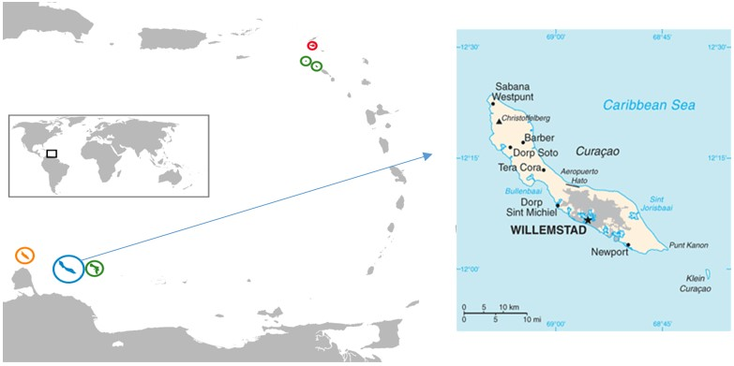
Figure 1 – Map of the Dutch Caribbean and Curaçao. Source: Wikipedia (adjusted by author).

Today, the island population comprises more than 100 nationalities. Curaçao’s official languages are Dutch and, since 2007, Papiamentu and English, while Spanish is also widely spoken. Papiamentu, a Spanish/Portuguese-based creole with elements from West-African languages, Dutch and English, is most widely spoken on the island. This is also reflected in the island’s bursting media landscape. In 2016, there were 28 licensed radio stations, 8 newspapers and at least 3 television stations – the vast majority in Papiamentu (Pin et al. 2016).
I set foot on Curaçao at the end of August 2015. This was a period during which many local (and European Dutch) newspapers and news websites were taking a look back on the five years since the constitutional reform of 10 October 2010. This is a key date, commonly referred to as 10/10/10, when the Netherlands Antilles, the political construct that had held the Dutch Caribbean islands together since 1954, ceased to exist and Curaçao became a constituent country within the Kingdom of The Netherlands. As such, Curaçao became responsible for regulating its own domestic affairs without interference from other Kingdom partners, predominantly The Netherlands. Only a limited number of policy areas are decided on at the Kingdom level, such as foreign policy, defence, citizenship, and the safeguarding of good governance (Veenendaal and Oostindie 2018: 31). But while the four Kingdom countries are formally equivalent, unequal relationships are constitutionally preserved by a democratic deficit through which the Caribbean countries are largely excluded from political decision-making at the Kingdom level. Since 2010 the Dutch government has increasingly intervened in the islands’ internal governance via the Kingdom Council (executive organ Kingdom government), consisting of the Council of Ministers of the Netherlands and one Minister Plenipotentiary of each Caribbean Kingdom country. As such, the Caribbean countries are represented yet are far outnumbered by representatives from the European Netherlands. This has led to dissatisfaction and a rhetoric voiced by political and intellectual elites on the islands that claims that a ‘recolonization’ is afoot.
Apart from political rhetoric on both sides of the ocean, the majority of the islanders share an understanding of the need for constitutional ties with the Dutch Kingdom. Curaçao has seen ongoing political instability and 9 different cabinets in a decade’s time (2010-2020). The first Prime Minister of Curaçao, Gerrit Schotte, would later be convicted of political bribery, forgery, and money laundering committed both during his legislative term (2010-2012) and his political career since 2007. In 2013, Curaçao was shaken by the assassination of the popular politician, Helmin Wiels. It is widely believed that he was killed because of his critiques of political corruption and the gambling industry on Curaçao.
Ordinary residents on Curaçao were on the receiving ends of these institutional problems and the persistent economic recessions they perpetuated. Since 2010, between one-quarter to over one-third of Curaçaoan households had been considered living below the poverty line. Structural poverty often interacted with severe social problems, among which are high rates of (youth) unemployment, domestic violence, teenage pregnancies and (organized) crime. Since Dutch colonialism, Curaçao’s society had been based on a class-based order. For sure, there was a racialized component to this order, given that most of those finding themselves at the lower ranks of society were Afro-Curaçaoans (black). This, however, did not mean that all Afro-Curaçaoans were part of the lower classes. The revolt that had taken place in the late 1960s (which emerged as a labour protest against Shell), had caused an institutional shift from predominantly white to partially black. Today, the institutional public of Curaçao – the realm where politicians, business(wo/)men and media owners and managers, among others, are active – was mixed, as was the case for what I term the popular public or the everyday where different realities came to the fore, including of those among the lower classes without access to the institutional public, experiencing ongoing economic insecurity, neglect and a sense of unhomeliness. These experiences form my point departure in discussing practices of survivance in the face of uncertainty – as everyday news routines (turning events into stories) that ‘create a sense of presence and situational sentiments of chance (…) [that] cannot be reduced by causal reason or cultural contrasts’ but enacts an ‘actual sense of the real, a coincidence, an existential venture of uncertainty, and unnamable contradictions’ (Vizenor 2008: 16-17).
In the case I present in this paper, I follow ‘newsy stories of survivance’ around games of chance by focusing on the ‘orientations’ expressed and enacted through these. Here I build on Bryant and Knight’s conceptualization of ‘orientations’ to understand how ‘our future-oriented actions shape our understanding of the present, and its relationship with the past’ (2019: 16). Below, I start with my experiences during my fieldwork at the Èxtra, the largest Papiamentu-language newspaper on Curaçao, by focusing on everyday news routines around the lottery and, related to these, the obituaries. These news routines, I argue, serve a double function. While one can make the point that they are means by which the establishment keeps the mass in check, one can also argue that they represent imperfect ‘ways of transforming one’s immediate experience in order to make life more bearable and fulfilling’, and ‘that allow one to momentarily disengage from everyday situations the better to reengage with them, a way of making the world one’s own’ (Jackson 2016: 14). Along with being instruments of domination, these news practices are also employed and acted upon by Curaçaoans as practices of survivance.

Games of chance

Driving up the parking lot of the Èxtra, the main newspaper on Curaçao, I noticed how busy it was. Many people drove by, stopped their car in front of the office, stepped out and walked quickly to the mail slot next to the entrance door, after which they continued their journey elsewhere. Others parked their car to enter the Èxtra’s office, where they used one of the ballpoint pens attached to the reception desk to fill in their lucky number for the daily lottery. It was mid-November 2015 and only a week since I had started with my fieldwork at the Èxtra. At this point, I had gotten used to the daily coming and going of people at the building of the Èxtra as they handed in a piece of paper cut or torn out of the newspaper to take part in the newspaper’s lottery.
The Èxtra was located along a main road in the bario [neighbourhood], Mundo Nobo. Given the steep prices of electricity and the uncertainty of what tomorrow would bring, working-class Curaçaoans, including those living in Mundo Nobo, bought their electricity via Pagatinu [a prepaid card-based charging system]. There were more than sixty Aqualectra (Curaçao’s water and electricity company) service points across the island, yet its main office was located on the other side of the road from Èxtra. The Pagatinu building was a reminder of the daily difficulties in making ends meet. Many people crossed the road from Aqualectra to Èxtra and, in so doing, shifted their orientation from the difficulties of everyday life to the hope for a better future – that is, by trying to win the lottery.
With the newspaper in one’s hands, it was hard to miss the opportunity to win money. Right on the front page the daily cash price was mentioned under the heading ‘Gana ku Èxtra’ [Win with Èxtra]. At the back of the newspaper, there was a page outlined with advertisements and a box in the middle with the heading ‘GANA HOPI PLAKA. Kesh ku Èxtra’ [Win lots of money. Cash with Èxtra] [see Figure 2]. Here, one could find yesterday’s results of the newspaper’s lottery, which was attached to the biggest official drawing on the island, the Wega di Number [Game of Numbers]. The winning number of the Wega di Number was listed on top of a list with the winning numbers of related lotteries on Bonaire, Sint Maarten, and even the Dominican Republic. This is illustrative of the regional scope of lottery networks as well as Curaçaoans’ engagement with them. In the middle of the page, there was a blank form accompanied by the text, ‘Yenando bo number deseá di Wega Number Kòrsou pa awe i entregando e kupon na Èxtra, bo tin hopi chens di gana plaka kesh!!!’ [By filling in your lucky number for the Wega Number Kòrsou of today and handing in the coupon at Èxtra, you have a great chance to win cash!!!]. The lottery brought many Curaçaoans to the office of the Èxtra daily. They passed by to deposit their lucky number – filled in on the form back in the paper – to join the next day’s lottery.

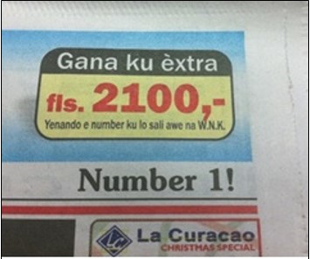 | 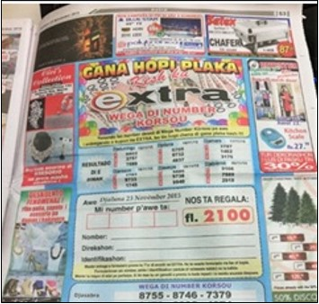
Figure 2 – [Left] Front page of the Èxtra. [Right] Lottery page in the back of the Èxtra (November 23, 2015).

There were many Curaçaoans whose everyday work was somehow linked to the Wega di Number or to one of the other lotteries present on the island. There is a history to this which began at the beginning of the 20th century. Back then, gambling was already very popular among Curaçaoans who bought their tickets from lotteries abroad. To counter the loss of capital to foreign countries resulting from this, the colonial government issued the Loterijverordening [National Ordinance on the Lottery] in 1909. This law enabled the Governor of Curaçao to issue permits to organize lotteries on the island (Landsloterij 2020). Yet, foreign lotteries and illegal gambling circuits continued to emerge and with that their popularity among Curaçaoans. Further legal measures were taken in 1949, when the state-owned Landsloterij was established, and in 1987, when the Wega di Number was legalized.
The institutional embedding of lotteries was accompanied by a growing labour force. There was a gendered aspect to this, and an economic one. Both were related to (changing) family structures on the island. Like elsewhere in the Caribbean, matrifocality (a family structure of interlinked relations centred around women in their role as mother) had prevailed among the Afro-Curaçaoan population until the early 20th century. This changed with the arrival of Royal Dutch Shell and the rapid processes of modern industrialization that followed. While the Church and Shell supported the nuclear family structure (e.g., providing services and financial benefits to married labourers), ‘the decline of women’s access to subsistence opportunities, together with full employment for men, caused an increase in the gap in earnings between the sexes’ (Abraham-Van der Mark 2003: 83). When lay-offs and economic recession set in, the position of those among Curaçao’s lower rankings worsened. Simultaneously, the number of ‘female-headed households increased, the divorce rate went up and the marriage rate went down’ (ibid: 85).
The female-headed households among Curaçao’s poor since the late 1960s were different from the matrifocal family structures of the past. Strong maternal support networks were no longer evident in modern-day Curaçao. They had been transformed into a patriarchal system. With only minimal assistance via the onderstand [welfare] and a karchi ku kuminda [resilience benefit, literally: food voucher], female heads of households in poverty (among whom were many single mothers) came to rely on their own creative ability to get some income – among others, by selling pastechis and bolo pretu [Curaçaoan street food], or through the resale of legal and illegal lottery tickets (Abraham-Van der Mark 2003: 83). During my fieldwork in 2015, I saw that these activities continued.
Since my start at the Èxtra I had often noticed an older woman sitting in a plastic chair in front of the paper’s building. Wearing a big fanny pack around her waist or a bag around her shoulder, a sun cap or long sleeves and many layers of clothing to cover her body from the sun, she always held a stack of brièchinan [tickets] for what I later found out to be the Landsloterij. Since its establishment in 1949, the Landsloterij had attained an important position in the Curaçaoan community. With its head office in the island’s capital, the Landsloterij generated funding for various community-based, arts and charity initiatives as well as employment for ‘elderly people in need of supplemental income’ (Landsloterij 2020: n.p.). Older working-class Curaçaoan women, whose chances for survival had long related to reselling (illegal) lottery tickets, were particularly represented. These days, there were over 600 Landsloterij resellers like the lady who sat in front of the Èxtra on Curaçao alone, a substantial number on an island with a population of around 155,000 officially registered people. And so ‘the lottery seller’ had become a cultural phenomenon on Curaçao [see Figure 3] and could be found along the busy Schottegatweg [Schottegat Road], at the snèk [snack bar], at shopping malls or banks; basically, at any location where they were likely to sell a numbered brièchi [ticket] to passers-by. Many resellers, however, had built up a loyal clientele of elderly Curaçaoans who had great faith in their lucky number, which could only be reserved by personal agreement with a particular reseller.

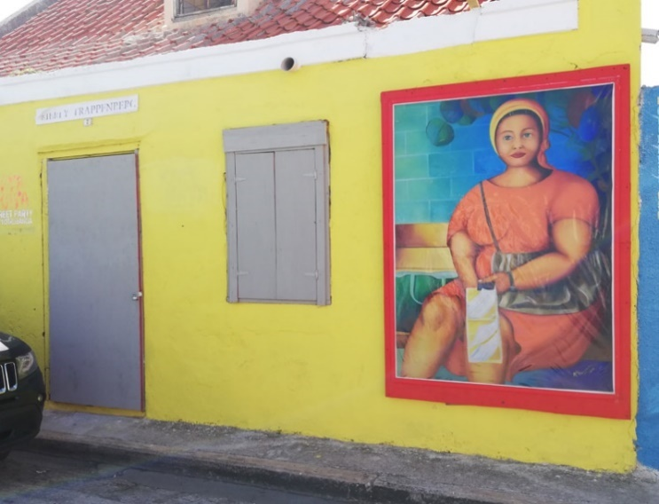
Figure 3 – Wall-painting ‘The Lottery Seller’ by artist Merly Trappenberg in Otrobanda, Willemstad. Source: Trendbeheer (Dees 2019).

Against all odds

The belief that certain numbers, events, persons, or places would bring good or bad luck was certainly not limited to the island’s working classes, nor to its elderly, yet it did relate to the lack of stability in one’s life and the future orientations that sprouted from this. There was also a lingering hidden poverty among Curaçaoans, including those who had moved to The Netherlands in the hope of a better life. In a 2017 newscast on persistent poverty and gambling addiction among Curaçaoan elderly in The Netherlands, one of the interviewees said: ‘You know what it is in life? You need to keep problems for yourself. (…) You don’t have to bring [them] out on the street’ (in Jones 2017).
While living in Fleur de Marie, one of Curaçao’s poorest neighbourhoods, I often went out for a late-night snack or drink. I only had to walk around the corner, 100 meters, to find my favourite bentana [home shops] where Giuliana sold some late-night necessaries via an opened window in her home. After several visits, Giuliana told me that she was a single mum of four children, three daughters and a son. She did not expect to become pregnant with her first daughter as a teenager while still at school. She soon dropped out when she was expecting her second daughter and the father left out of sight. The father of her youngest daughter and son was still around, but they did not live together. When I asked her how she managed making ends meet, Giuliana said she had to be creative by selling late-night groceries and by cleaning hotels during the day, but she quickly assured me that neither she nor her daughters were like ‘the ladies of Fleur de Marie’ – hinting to the Latin-American women who sold their bodies to Curaçaoan men to get some income. During the past decade, Fleur de Marie indeed had seen an influx of Spanish-speaking immigrants, not least via human trafficking and (forced) prostitution, yet the latter was certainly not exclusive to these ‘ladies’. I was confronted with the latter when I walked towards Giuliana’s bentana one night, and suddenly noticed two men, one walking in and the other out of her house. At that moment, I decided to walk to the corner street café in the opposite direction, only to find a dozen men surrounding some of ‘the ladies of Fleur de Marie’ that Giuliana might have been talking about.
Airing one’s dirty laundry in public, including one’s poverty and the necessary means to endure this, was frowned upon among Curaçaoans. One was expected to keep up appearances and act ‘respectable’ – a social norm that reflected the ongoing legacies of the colonial socio-political system. This system was in place until the late 19th century. The status of the ‘white’ shon [master] was maintained by the respèt [respect] the subordinated katibu [enslaved] had to show (see Hoetink 1958). After the formal Dutch abolition of slavery in 1863, the Roman Catholic Church took on its Mission to ‘civilize’ the formerly enslaved Curaçaoans and educate them to become hende drechi [decent people] (Allen 2007: 149; 172). Among Curaçaoans social control of norms of behavior on the importance of acting ‘respectable’ persisted up until today. Behavior that is considered faltu di respèt [disrespectful] and sinberguensa [shameless] is often publicly condemned, based on the association with hende brua [rude people] – those who must be ‘civilized’ and who are at the bottom and the margins of society. During my fieldwork, however, that this history was first and foremost enacted by hende dreche among the island’s middle-classes, in fearful anticipation of becoming hende brua and thereby losing one’s social status.
I experienced this quite closely when a friend lost a respected job in the e-consultancy business on the island. She hid at home and went hungry until finding new work just as prestigious rather than accepting what she considered to be a less respected job, such as working in hospitality. Losing one’s social status formed a real risk for those who had a certain status to maintain. This was certainly the case for those among the (higher) middle-classes who aspired the become part of the elites (wealthy CEOs and landowners). In Curaçao’s class-based social order, the higher one went up, the smaller the island got. Among elites everyone knew everyone through nètwèrks [networks] as these close and opaque webs of elite relations were commonly referred to (Römer 2017: 198-99). For those who aspired to become part of these exclusive nètwèrks, there was a lingering fear of losing one’s job, and with that, one’s face (and thus privilege) overnight.
For most Curaçaoans, however, it was not about what one could lose, it was about what could be won. And from this perspective, airing your dirty laundry – or publicly speaking up, for that matter – was not (only) shameful or fearful, but considered utterly unwise. I learned through my engagements with Giuliana and others that ‘[f]or people without power,’ as anthropologist Michael Jackson argued, ‘the skills of stealth, cunning, dissociation, two-facedness, and even trickery become means of survival’ (2016: 127).
Institutional actors, in turn, acted upon these means and knowledges of survival among Curaçao’s poor. A case in point was the Landsloterij campaign launched in 2019. With the slogan ‘AT’ABO SA!’ [Look! You know!], the aim was to attract young(er) Curaçaoans. The popular Curaçaoan rapper, Dongo, became the face of this campaign in newspaper advertisements, TV commercials, and on billboards along busy roads. Accompanied by hashtags #WannaBeAMillionaire and #Gana1Mion [Win 1 million], a series of clips circulated on social media in which Dongo jumped on a shopping cart and ‘surfed’ through a supermarket grabbing as much as he could in one minute [see Figure 3]. These clips were meant to be funny and ironic at the same time. Instead of hiding greed, shame, fear, and hope, the campaign starring Dongo unpacked and enlarged these shared feelings in Curaçao’s society. It did so in satirical contrast to everyday realities on the island, especially of the poor for whom such goods were largely inaccessible.
This too was the case for Dongo’s video clip Brièchi that became a hit with over 50,000 views on YouTube in 2019. The chorus of the song spoke to what was common knowledge and practice among Curaçaoans: ‘Tur hende ke gana (Brièchi!) | Bintidos Wega pa aña (Brièchi!) | Kumpra un kas pabo mama (Brièchi)!’ [Everyone wants to win (Ticket!)| Twenty-two draws a year (Ticket!)| Buying a house for your mom (Ticket!)]. The latter bit articulated the reality of female-headed households (including single-mothers) among Curaçao’s lower classes as well as illustrating the financial support that was expected of children for their mother(s). The latter was (or could be) an act of love for one’s caregivers. It was also a social norm of ‘respectability’. Yet more than displaying the dreams that could be fulfilled if one won the lottery, Dongo’s video clip spoke to Curaçaoans by ridiculing acting ‘respectable’ in terms of pretending one was someone one was not. An example of this was a scene featuring Dongo making a selfie while on a jet ski with two ladies (one of them waving a stack of lottery tickets). The scene speaks to dreams of owning a jet ski, while ridiculing acting ‘as if’ one already has one (it only becomes clear that this jet ski is placed in a rental truck when the camera zooms out). Another scene shows Dongo walking to a luxurious car he seemed to remotely open, only to find out he is holding the keys of his bicycle parked next to it [see Figure 4].
As a popular rapper who knew bida den kaya [street life], Dongo also articulated the sense of what Curaçaoans called bida den miseria [miserable life]. In 2015 Dongo released another hit-track: Bida [Life]. In contrast to the video clip for Brièchi, which showed what the Curaçaoans longed for, shots from the music video for Bida illustrated what those living in the poor bario wished to escape, namely tur kos malu [all bad things] as the result of poverty, feelings of misery, and persistent stigmatization and discrimination [see Figure 5].
Compared to the brightly-coloured clip of Brièchi, the clip of Bida showed dusty yellow-ish shots which reflected how the island was often covered by dusty Sahara sand carried by the ever-present passaatwind [trade wind]. Life at the lower rungs of society was rough and dirty. Yet, it was also full of moments of joy, of care, and of comradery, as well as of freedom to focus on these. This was at the core of the song’s lyrics, for example in: ‘Bo ke kore den Benz anto ami ta draai riba sunny’ [You think about driving your Benz, but I turn towards sunny (the light)]. Thrown into this life, one had a choice to focus on what it offered, rather than on what it lacked. This message spoke to many on and beyond Curaçao. Bida had more than 1.4 million views on YouTube (December 2021).
By attracting a popular rap artist, the Landsloterij used channels of mass-popular culture to capitalize on the modes through which Curaçao’s poor expressed aspirations and dreams of (a better) life. Buying one’s brièchi was such an expression. That is, of an orientation of hope that reflected deeper social concerns about the insecurity and instability many Curaçaoans had to live by or, rather, made the most of. There was an irony to this orientation of hope that wasn’t quite captured when focusing solely on the message of Dongo’s clip Bida in terms of ‘always look at the bright sight of life’. The clip spoke to the widespread experience among Curaçaoans with daily struggles to make ends meet. For those living in poverty, turning ‘towards sunny’ was not about being positive, but often meant: a creative endurance, in the hope for a better future against all odds.

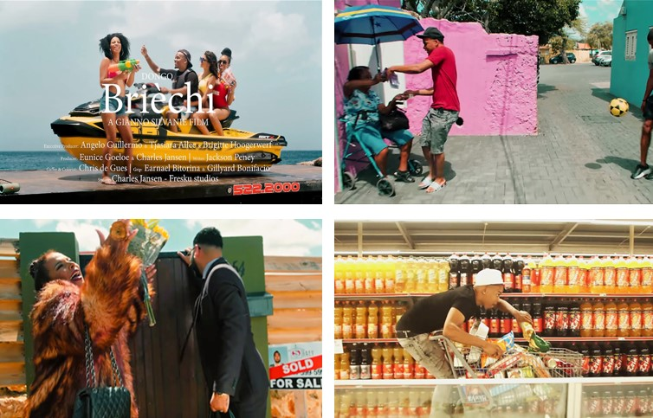
Figure 4 – Screen shots from the ‘At’Abo Sa!’ [Look, you know!] campaign of the Landsloterij in 2019. From left top to bottom right: stills from the video clip Brièchi, featuring: 1. Dongo taking a selfie while on a jet ski placed in a rental truck with two ladies (one them waving a stack of lottery tickets). 2. Dongo buying his brièchi from ‘the lottery seller’; 3. An ecstatic mom, wearing a fur coat, luxurious jewellery, and holding a Chanel bag, as she receives the keys of a new house (Teamdongo 2019); 4. Still from a Landsloterij advertisement with Dongo jumping on a shopping cart in a one-minute supermarket run (Èxtra 2019).

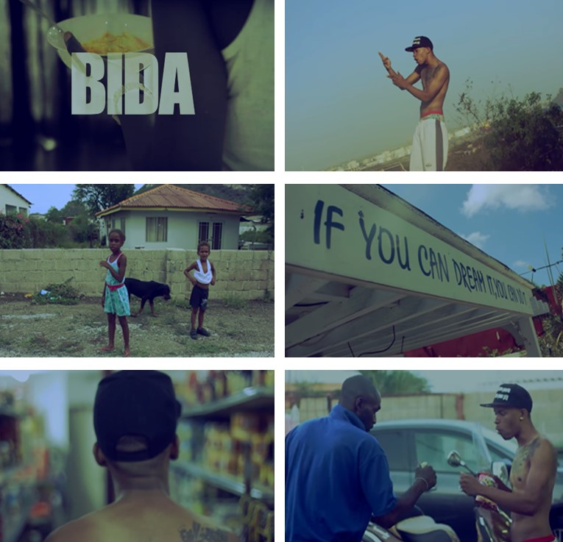
Figure 5 – Screen shots from the video clip Bida (Teamdongo, 2015). From top left to bottom right: 1. Dongo eating funchi ku jogurt [funchi with yogurt], a staple dish among Curaçaoans; 2. Dongo illustrating the violence one faces living the bida den kaya in front of the Isla oil refinery which produces pollution that affects the poor barios on the west side most; 3. Dongo ta bai keiru [drives around] – a common practice and saying on the island – while passing children and a kachó di kaya [street dog], whose life is often compared to that of the Curaçaoan poor; 4. Text on a building, saying: ‘If you can dream it, you can do it’; 5. The latter is countered with Dongo entering a toko when the shot turns blurry; ‘dikon ni ta pasa tampoko ma bida ta blur’ [why nothing happens, my life is blurred]; 6. Dongo raps: ‘mi ta diskrimina dilanti pa bai riba junkies’ [I am discriminated against for going to junkies], while he gives a neighbour some cash for cleaning his (old) car.

Winning and losing: the facts of life

I remember being rather sceptical about its lottery as I started my fieldwork at Èxtra. This scepticism originated from my own (bourgeois) middle-class upbringing and education underpinned by liberal-democratic ideals of transparency, objectivity and rational-critical deliberation. It was based on notions of the lottery being a ‘tax on stupidity’ and, basically, a losing game: participating in games of chance was rationally biased and the hope for winning someday was an illusion. This reasoning was shared by members of the (upper) middle-classes on Curaçao, including (formally educated) journalists working at or with news media that catered to those belonging to the higher rungs of the island’s social order.
This was different for the Èxtra, though, which held the biggest market share of the island’s news industry. When I expressed my scepticism to the newspaper’s chief-editor, Marc, he replied: ‘The lottery is something of this people. It’s just a fact of life. It’s just a fact of life’ (interview with Marc, 11 December 2015). With ‘this people’, Marc who belonged to the (darker-skinned) middle-classes, distanced himself from those for whom the lottery was, indeed, a fact of life. Yet, at the same time, for us both – sitting in the Èxtra’s editorial room – the lottery formed ‘a fact of life’ too. The full page dedicated to the lottery in the back of the daily made the lottery a daily life event. It provided ‘the news’ on numbers, drawings, and results, while simultaneously perpetuating feelings of hope and fear as reflections of the lottery as a story of life.
This story specifically spoke to Curaçao’s working classes. They lived life day-by-day with the only certainty being that life was uncertain and, ultimately, a game of chance. In the face of an unknown tomorrow, Curaçao’s poor – but, in reality, all of us – experienced an unsettling anxiety. Their lottery-related practices of newsmaking (including dissemination, selling, buying, and consuming) were a reminder that we all were thrown into ‘the lottery of life’ – a world full of chance.
This was probably best illustrated by the evening programming on television, which continued to be the most popular medium among Curaçaoans (CBS 2018). Each night, Curaçaoans tuned in to the main channel of TeleCuraçao, Curaçao’s public broadcaster, to find out whether today was their lucky day. The daily draw of the Wega di Number had among the highest ratings on national television. And even if one tuned in to a different channel, one could not avoid the smaller viewing box broadcasting the draw in the corner of one’s screen. And so, I experienced how the live broadcast was on screen in almost every Curaçaoan living room, in cafés, snèks, and late-night offices, including Èxtra’s newsroom, where I noticed editors and reporters looking up from their desk and watching the TV hanging above them as soon as the numbers were drawn.
Immediately after the day’s winners were decided by a randomly drawn series of numbers, the evening programming continued with what appeared to be that other, yet definitely more certain, ‘fact of life’: death. In the program Partisipashon di Morto [Mentioning of the Death], the names of those who had died were announced – or, at least, the names of those whose families could afford and were willing to pay 100 NAF (around 56 USD) or, when including a picture of the person, 175 NAF (close to 100 USD) [see Figure 6].

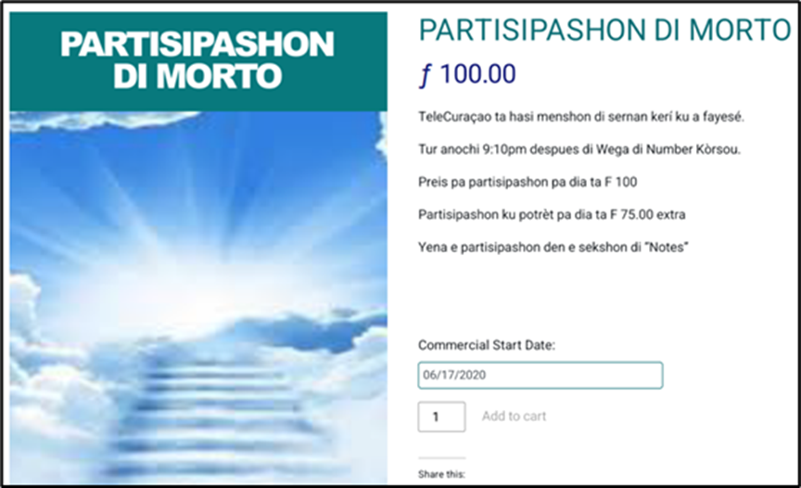
Figure 6 – Screenshot from TeleCuraçao’s business page for ‘Partisipashon di Morto’ (taken on 16 June 2020).

Publication of the names of those who had passed on was extremely important to Curaçaoans and deeply embedded in practices of newsmaking. The founder of the Èxtra told me that the daily obituaries in the Èxtra formed, in fact, the main reason that the newspaper had attained and maintained its dominant position in the local press. Chief-editor Marc added the following explanation of why the obituaries were so important to Curaçaoans:

If you buy the Èxtra in the morning, then you know (…) all of whom passed away. Verrryyy important for the Curaçaoan community. To know all who passed away and when the funeral is! [punches fist on the table]. Because contrary to The Netherlands, here you don’t receive an invitation to – no! You are expected that you – you know that person, or you know his sister, or you know his brother, or you know his brother-in-law, or whomever – come to the funeral. Ok? Then [by reading the Èxtra – SR] everyone knows it. Very important. (Interview with Marc, 11 December 2015)

Here, the chief-editor related news practices around funerals to social norms of what I described above as acting ‘respectable’. On Curaçao, one did not receive an announcement with information about a funeral, nor was one personally notified in case someone had passed. Instead, one was expected to know and to subsequently show up at a funeral out of respect for the one that had passed on and their loved ones (see Allen 2007: 248-49). This expectation of knowing who had passed and acting ‘respectable’ by attending a funeral had generated popular news practices of buying the Èxtra, in which, according to its management, 99% of the daily obituaries could be found.
Respectability was but one aspect however, as I came to realize. Checking the daily obituaries formed a daily future-oriented news routine among Curaçaoans. Attending a funeral was not solely about respectability but also a joint reminder that chance and unpredictability were parts of life for everyone regardless of one’s social station. In a similar way, news practices around games of chance – from the daily routine of handing in one’s lucky number at the Èxtra and buying one’s brièchi to watching the live broadcast of the daily drawing – reflected a shared need among Curaçaoans to navigate uncertainty. News practices around both obituaries and lotteries highlighted the slogan of the Landsloterij, ‘AT’ABO SA!’ [Look, you know!], because one had to know and, at the same time, longed to know. And this two-fold motive for engaging with ‘the news’ was known to all (you know?). It was therefore no coincidence that the Wega di Number and the Partisipashon di Morto were broadcast during the same (prime) time slot at night. It also explained why – and this was common knowledge on the island – Curaçaoans read the newspaper from future to present. Many made sure to first check out the ‘new’ and ‘noteworthy’ – that is, who had lost (obituaries) and who had won (lottery results) – before turning to ‘the news’ about recent events in the rest of the newspaper. Curaçaoans jointly oriented towards the future: its endless possibilities and the ultimate inevitable. And in doing so, they put their faith in God that ultimately decided who would win the next draw and whose life would end tomorrow.

Tomorrow, ku Dios ke

Among Curaçaoans, God was bida [life] in all its complexity and contingency. Like any other who participated in quotidian island life, I was frequently reminded by God’s presence, particularly in forms of sociality. It was common to remind each other of God’s omnipresence upon greeting, in small talk, during deeper conversations, and upon leaving. These social practices had been passed over from (and through) generations. ‘All these expressions stem from the concept of a Supreme Being determining everyone’s lives,’ as Allen argued in her (oral) historical study of Afro-Curaçaoan culture, adding that this concept ‘was also manifest when one made plans for the future’ (2007: 240). One of Allen’s interviewees clearly articulated this shared orientation and how it informed everyday social conventions:

You must not say ‘till tomorrow’. You are not allowed to. You must say: ‘Till tomorrow with God’s will.’ Then God will know that you have faith in Him. Because if God doesn’t want to, you cannot see tomorrow. Nowadays people talk without thinking how they have to say the words. ‘Till tomorrow...?’ You don’t know. You may die today. (Edouardo Tokaai in Allen 2007: 240)

Yet, perhaps more than an expression of genuine faith in God ‘to control fate’ and that ‘his power was evident in all aspects of life, such as the search for work, whether or not it would rain and the potential of a newly dug well’ (Allen 2007: 237), the above account expressed how reminding each other of God’s will was an articulation of chance (‘You don’t know. You may die today.’).
This outlook on the life of today and tomorrow continued to be an important means to navigate uncertainty among Curaçaoans. In my conversation with David and Yordan, the initiators of a popular satirical weblog on the particularities of Curaçaoan culture, they reflected on the ongoing expression of ‘ku Dios ke’ [God Willing] in daily island life:

David: That’s culture, that is deeply rooted. Yes, and you hear it back in particular sentences we standardly use. If I say to my mom: ‘I will go to Trinidad and Tobago with my girlfriend in November’, then she says to me— and she often says this: ‘God Willing’ and ‘it could be so that’—

Yordan: ‘ku Dios ke’.

David: Your mother is caring. She says that to you and the message is that [she wants] you [to] be happy. And that God’s Will ultimately determines this.

Yordan: ‘I have a job at the McDonald’s. That must be God’s Will that I, that I’— they are searching for acceptance, I think. (Interview with David and Yordan, 31 October 2015)

Here, David and Yordan reflected upon several reasons for why ‘ku Dios ke’ was so deeply embedded in daily communication among Curaçaoans – from a wish for one to be happy to a search for acceptance. Either way, with the expression of ‘ku Dios ke’ Curaçaoans recalled that life – just as death – was ultimately ‘God Willing’. Yet, while for David and Yordan (two successful black middle-class professionals in their thirties), ku Dios ke merely signalled ‘an impulse to passively “persevere in being”’, I learned that the notion of God Willing also consisted of ‘the search for “adequate ideas” that enable us to actively sustain our sense of presence and purpose’ (Ricoeur 1992: 316, in Jackson and Piette 2015: 12).
A few months after my conversation with David and Yordan, I met with Soraya in the MacDonald’s at a busy crossroad of the Schottegatweg. By that time, I had become quite familiar with central meeting spots like these – the Starbucks in Riffort was another case in point – where Curaçaoan professionals, entrepreneurs, and expats came to work and socialize. Soraya worked for the daily news cast at TeleCuraçao. She came from a black working-class background and had been able to climb the social ladder through following a journalism training in The Netherlands. During our conversation, she reflected upon the uncertainties she and her close ones were facing in the wake of the constitutional reform in 2010, by which the island became an autonomous country as part of the Kingdom of the Netherlands, saying:

Look, life’s getting harder, you know? It’s quite a cliché, but if I look at myself, I notice that, yes, the more autonomous we become, the further we go into the 21st century, the harder life gets. It’s thus a sort of struggle of how do I survive? What makes me happy? (Interview with Soraya, 27 May 2016)

Here, Soraya pointed to the struggle many Curaçaoans had increasingly faced – and continued to do so – in terms of securing income, employment, and being happy, as time moved on. As she posed the questions above, I looked up at the counter where three employees were sharing a joke. It reminded me of my conversation with David and Yordan. I wondered whether working at the MacDonald’s, ku Dios ke, was necessarily a search for acceptance or could also be an acknowledgement of the chances immanent to life. In this way, reminding each other of ku Dios ke could also resemble ‘enacted destiny’, ‘an idea of divine empowerment, which enables believers to deal with risk and contingency’ (Nieswand 2010: 51, in Bryant and Knight 2019: 174).
At the same time, it could also serve as a reminder that all – including those belonging to higher rungs in society – were subjected to God’s Will. Differently put, faced with deeply felt uncertainty, many Curaçaoans acknowledged that the future was in fact unknown, also for those with earthly powers. As such, they practiced news abundantly by tuning in to radio programs that were brought to them by individual politicians; by lining up before cameras whenever the Dutch Royals visited the island; by sharing the talk of the town as they went to church; by buying their brièchi at ‘the lottery seller’ and handing in their lucky number at the Èxtra. For many institutional actors, these practices of news formed a puzzling paradox – one that was often understood as the result of either an emotion-versus-rationality dichotomy, of ‘false consciousness’ or, else to an overall lack of education among Curaçaoans, especially the poor. However, there was no paradox. Curaçaoans, particularly those who found themselves at the bottom of the island’s social order could only win (or safeguard the very little they had) by acting as though they were ‘aping their betters’ or in other ways behaving as people from the middle classes would. Persistent economic dependency, and the daily struggles to make ends meet that came with this, forced many on the island to be receptive to services, materials, and goods provided by those in power – including a job at the MacDonald’s. At the same time, many putted their faith in and hope for a better life someday. There was nothing irrational to this pragmatic future-oriented outlook as articulated and enacted in everyday news routines. After all, as Calkins (2016) reminds us, ‘who knows the future?’ Based on a similar rationale, by purchasing a lottery ticket, many Curaçaoans were ‘not taking a risk or risking their money (given the very long odds), they [were] orienting positively to and embracing chance’ (Cosgrave 2021: 131). They knew that life was, in fact, a lottery. And so, they celebrated this life full of chance, knowing that no living soul could escape this contingency.

Conclusion

My aim in this paper has been to explore how practices of survivance (Vizenor 2008) might be conceptualized according to the localities and temporalities expressed through everyday news routines on Curaçao. I have focused on how Curaçaoans navigate uncertainty through future-oriented news routines around games of chance and, related to these, the obituaries. In the case I have presented, this means practicing news in the hope for a better future (lottery) and in anticipation of a future that is inevitable (obituaries). While the first speaks to an unknown future that is desired, the second speaks to the immanence of an inevitable future full of chance. Whereas institutional actors (in politics, business, media) on the island and in the Dutch world orientate toward mitigating uncertainty and anticipating risk – also, at times, in relation to capitalizing on desires and hopes – I have argued that everyday news routines around the lottery (of life) may also be interpreted as how Curaçaoans, especially those marginalized and without access to the institutional public, creatively navigate uncertainty by embracing chance. Orienting towards the future fed feelings of fear, yet it was also what bared hope. It was where the imagination for potential (better) futures sprouted.
From the daily routine of handing in one’s lucky number at the Èxtra and buying one’s brièchi to watching the live broadcast of the daily drawing, news practices around the lottery reflected a shared future orientation of hope. For Curaçaoans facing severe poverty and hardships, buying a lot was not about whether this was worth the risk. After all, they had nothing to lose really. At the same time, they also reminded each other of what in fact could be lost – an uncertainty that all human beings, including those in power, had to deal with. This acknowledgement of an inevitable future, which was also unknown, was not one of passive awaiting, but one that enacted survivance, as a (singular) sense of presence (Vizenor 2008). It enabled them to take a hand in their lot by ‘orienting positively to and embracing chance’ (Cosgrave 2021: 131) in the hope for a better life one day, ku Dios ke.

Bibliography

Allen, Rose Mary 2007. Di ki manera? A social history of Afro-Curaçaoans, 1863–1917, Amsterdam: SWP.

Abraham-Van der Mark, Eva 2003. Continuity and change in the Afro-Caribbean family in Curaçao in the twentieth century, Community, Work and Family 6/1, 77-88. doi:10.1080/1366880032000063914

Bryant, Rebecca and Daniel M. Knight 2019. The anthropology of the future, Cambridge: Cambridge University Press. doi:10.1017/9781108378277

Burns, Lorna 2009. Becoming-postcolonial, becoming-Caribbean: Édouard Glissant and the poetics of creolization, Textual Practice 23/1, 99-117. doi:10.1080/09502360802622300

Calkins, Sandra 2016. Who knows tomorrow? Uncertainty in North-eastern Sudan, New York: Berghahn.

Cosgrave, James F. 2021. Celebrating the contingent: the modern lottery as collective representation in late capitalism, Canadian Journal of Sociology 46/2, 121-46. https://perma.cc/5TFB-NBEZ.

Dees, Sasha 2019. Publieke kunstwerken in Otrobanda Curaçao, Trendbeheer https://perma.cc/4JPG-PS4N (accessed 21 Aug 2020)

Èxtra 2019, March 29. Ata bo sa: Kampaña di Landsloterij ku artista urbano Dongo. https://perma.cc/8MXN-VK8X (accessed 11 Aug 2020).

Hall, Stuart 2015. Creolité and the process of creolization, in Encarnación G. Rodríguez and Shirley A. Tate (eds.), Creolizing Europe: legacies and transformations, 12-25. Liverpool: Liverpool University Press. doi: https://doi.org/10.2307/j.ctt1gn6d5h.6

Glissant, Édouard 1995. Creolization and the making of the Americas, in Vera L. Hyatt and Rex Nettleford (eds.), Race, discourse, and the origin of the Americas, 266-75. Washington and London: Smithsonian Institute Press.
——— 1997. Poetics of relation, Michigan: University of Michigan Press.

Hoetink, Harry 1958. Het patroon van de oude Curaçaose samenleving, Assen: Van Gorcum.

Jackson, Michael 2016. As wide as the world is wise: reinventing philosophical anthropology, New York: Columbia University Press.

Jackson, Michael and Albert Piette (eds.) 2015. What is existential anthropology? New York: Berghahn.

Jones, Sam 2017. Antilliaanse ouderen aan lager wal door schulden en lootjes. NTR Caribisch Netwerk https://perma.cc/4DUL-9MH4 (accessed 18 Sept 2019).

Landsloterij 2020. History. https://perma.cc/CK2C-JKSJ (accessed 23 Feb 2022).

Murdoch, H. Adlai 2015. Glissant’s opacité and the re-conceptualization of identity, New York: Rowman and Littlefield.

Nieswand, Boris 2010. Enacted destiny: West African charismatic Christians in Berlin and the immanence of God, Journal of Religion in Africa 40/1, 33-59.

Oxford Languages. News. https://perma.cc/YAG3-B7RE (accessed 28 Feb 2022).

Pin, Renske, Suzan van Velzen and Irwin Korstjens 2016. Assessment of media development in Curaçao based on Unesco's media development indicators, Kingston: Unesco.

Pugh, Jonathan and David Chandler 2023. The world as abyss: the Caribbean and critical thought in the Anthropocene, London: University of Westminster Press.

Qracao 2014. Wega di Number verliest dominantie op tv. https://perma.cc/HDU4-E9ZG
(accessed 19 May 2015).

Ricoeur, Paul 1992. Oneself as another, Chicago: University of Chicago Press.

Römer, Louis-Philippe 2017. Speaking like a sovereign public: talk radio, imperial aftermaths and political aspirations in Curaçao, New York: D.Phil. thesis.

Rotmeijer, Sanne 2023. News in a glasshouse: media, publics, and senses of belonging in the Dutch Caribbean, Leiden: D.Phil. thesis.

Teamdongo 2015. Bida. YouTube https://perma.cc/G5PG-8EE3 (accessed 11 Feb 2022).
——— 2019. Brièchi. YouTube https://perma.cc/2CZS-PAVE (accessed 11 Feb 2022).

Veenendaal, Wouter and Gert Oostindie 2018. Head versus heart: The ambiguities of non-sovereignty in the Dutch Caribbean. Regional and Federal Studies 28/1, 25-45. doi:10.1080/13597566.2017.1368018

Vizenor, Gerald 1998. Fugitive poses: Native American Indian scenes of absence and presence, Lincoln: University of Nebraska Press.
——— 2008. Native liberty: natural reason and cultural survivance, Lincoln: University of Nebraska Press.

This work is copyright of the author.

It has been published by JASO under a Creative Commons Attribution-NonCommercial-ShareAlike License (CC BY NC 4.0) that allows others to share the work with an acknowledgement of the work's authorship and initial publication in this journal as long as it is non-commercial and that those using the work must agree to distribute it under the same license as the original. http://creativecommons.org/licenses/by/4.0/)

Senior Lecturer in anthropology and interdisciplinary social sciences at the Department of Social and Behavioural Sciences, University of Amsterdam, The Netherlands. Email: s.rotmeijer@uva.nl
Curaçao’s gambling sector was a public-private industry and increasingly so on a global scale. In the late 1990s, a law was enforced that left space for major gambling companies – self-acclaimed ‘Master Licence’ holders – to provide sub-licences to global actors across the world.
In fact, only since 2014 has the live broadcast of the drawing no longer entirely interrupted other programs running on national TV (Qracao 2014).
NAF stands for Netherlands Antilles Guilder, which is the official currency of Curaçao (and Sint Maarten). NAF is pegged to the US dollar (1 NAF ≈ $ 0.55).

